IMPROVING THE STUDENTS’ SPEAKING SKILL THROUGH VIDEO DUBBING AT THE ELEVENTH GRADE OF PRIVATE ISLAMIC SENIOR HIGH SCHOOL AMALIYAH SUNGGAL IN 2018/2019 ACADEMIC YEAR

A SKRIPSI
Submitted to the Faculty of Tarbiyah and Teachers Training State Islamic University of North Sumatera Medan as a Partial Fulfillment of the Requirements for the Degree of Sarjana Pendidikan

By:
KIKI AMALIA
NIM: 34143076

DEPARTEMENT OF ENGLISH EDUCATION
FACULTY OF TARBIYAH AND TEACHERS TRAINING
STATE ISLAMIC UNIVERSITY OF
NORTH SUMATERA
MEDAN
2018

IMPROVING THE STUDENTS’ SPEAKING SKILL THROUGH VIDEO DUBBING AT THE ELEVENTH GRADE OF PRIVATE ISLAMIC SENIOR HIGH SCHOOL AMALIYAH SUNGGAL IN 2018/2019 ACADEMIC YEAR

A SKRIPSI
Submitted to the Faculty of Tarbiyah and Teachers Training State Islamic University of North Sumatera Medan as a Partial Fulfillment of the Requirements for the Degree of Sarjana Pendidikan

By:

KIKI AMALIA
NIM: 34143076
Advisor I Advisor II

Dr. Abdillah, M.Pd. Dr. H. Syaukani, M.Ed., Adm.
NIP: 19680805 199703 1 002 NIP: 19600716 1986031 1 002

DEPARTEMENT OF ENGLISH EDUCATION
FACULTY OF TARBIYAH AND TEACHERS TRAINING
STATE ISLAMIC UNIVERSITY OF
NORTH SUMATERA
MEDAN
2018
Nomor : Istimewa Medan, Agustus 2018
Lamp : 6 (Enam) Eks Kepada Yth,
Perihal : Skripsi Bapak Dekan Fakultas
Ilmu Tarbiyah dan Keguruan
a.n Kiki Amalia UIN Sumatera Utara
di
Medan
Assalamu’alaikum Wr.Wb
Dengan Hormat,
Setelah membaca, meneliti, dan memberi saran-saran perbaikan seperlunya terhadap skripsi mahasiswa a.n Kiki Amalia yang berjudul “Improving the Students’ Speaking Skill through Video Dubbing at the Eleventh Grade of Private Islamic Senior High School Amaliyah Sunggal in 2018/2019 Academic Year”, maka kami berpendapat bahwa skripsi ini sudah dapat diterima dan dimunaqasyahkan pada sidang Munaqasyah Fakultas Ilmu Tarbiyah dan Keguruan UIN Sumatera Utara Medan.
Demikian kami sampaikan, atas perhatian saudara kami ucapkan terima kasih.
Wassalam,
Advisor I Advisor II

Dr. Abdillah, M.Pd. Dr. H. Syaukani, M.Ed., Adm.
NIP: 19680805 199703 1 002 NIP: 19600716 1986031 1 002

KEMENTERIAN AGAMA
UNIVERSITAS ISLAM NEGERI SUMATERA UTARA
FAKULTAS ILMU TARBIYAH DAN KEGURUAN
Jl. Williem Iskandar Psr. V Medan Estate 20371 Telp. 6622925, Fax. 6615683

SURAT PENGESAHAN
Skripsi yang berjudul : “Improving the Students’ Speaking Skill through Video Dubbing at the Eleventh Grade of Private Islamic Senior High School Amaliyah Sunggal in 2018/2019 Academic Year” oleh Kiki Amalia, yang telah dimunaqasyahkan dalam sidang munaqasyah Sarjana Strata Satu (S1) Fakultas Ilmu Tarbiyah dan Keguruan Universitas Islam Negeri Sumatera Utara Medan pada tanggal:

21 Agustus 2018 M
09 Dzulhijjah 1439 H

dan telah diterima sebagai persyaratan untuk memperoleh gelar Sarjana Pendidikan (S.Pd) pada jurusan Pendidikan Bahasa Inggris Fakultas Ilmu Tarbiyah dan Keguruan Universitas Islam Negeri Sumatera Utara Medan.

Panitia Sidang Munaqasyah Skripsi
Fakultas Ilmu Tarbiyah dan Keguruan UIN SU Medan

Ketua Sekretaris

Dr. Sholihatul Hamidah Daulay, M.Hum. Maryati Salmiah, S.Pd., M.Hum.
NIP. 19750622 200312 2 002 NIP. 19820501 200901 2 012

Anggota Penguji

1. Dr. Abdillah, M.Pd. 2. Dr. H. Syaukani, M.Ed., Adm.
NIP. 19680805 199703 1 002 NIP. 19600716 1986031 1 002

3. Siti Ismahani, M.Hum. 4. Ernita Daulay, S.Pd., M.Hum.
NIP. 19690503 199903 2 003 NIP. 19801201 200912 2 003

Mengetahui
Dekan Fakultas Ilmu Tarbiyah dan Keguruan

Dr. Amiruddin Siahaan, M.Pd
NIP. 19601006 199403 1 002
PERNYATAAN KEASLIAN SKRIPSI

Saya yang bertanda tangan di bawah ini:
Nama : Kiki Amalia
Nim : 34143076
Jurusan/Program Studi : Pendidikan Bahasa Inggris/S-1
Judul Skripsi : “IMPROVING THE STUDENTS’ SPEAKING SKILL THROUGH VIDEO DUBBING AT THE ELEVENTH GRADE OF PRIVATE ISLAMIC SENIOR HIGH SCHOOL AMALIYAH SUNGGAL IN 2018/2019 ACADEMIC YEAR”
Menyatakan dengan sebenarnya bahwa skripsi yang saya serahkan ini benar-benar merupakan hasil karya sendiri, kecuali kutipan-kutipan dari ringkasan-ringkasan yang semuanya telah saya jelaskan sumbernya.
Apabila dikemdian hari terbukti atau dapat dibuktikan skripsi ini hasil ciplakan, maka gelar dan ijazah yang diberikan oleh Universitas batal saya terima.

Medan, Agustus 2018
Yang membuat pernyataan

KIKI AMALIA
NIM: 34143003
ABSTRACT

IMPROVING THE STUDENTS’ SPEAKING SKILL THROUGH VIDEO DUBBING AT THE ELEVENTH GRADE OF PRIVATE ISLAMIC SENIOR HIGH SCHOOL AMALIYAH SUNGGAL IN 2018/2019 ACADEMIC YEAR

KIKI AMALIA
34.14.3.076

Keyword: Video Dubbing Technique, Students’ Speaking Skill

This research aimed to improve the students’ speaking skill in English by applying video dubbing technique. This research was conducted by using Classroom Action Research (CAR). The objective of this research was to prove whether video dubbing technique can improve the students’ speaking skill at the eleventh grade of MAS Amaliyah Sunggal. The subject of this research was XI-IPA 3 MAS Amaliyah Sunggal in 2018/2019 academic year which consists of 41 students. This research was conducted in two cycles which each consists of planning, action, observation, and reflection. The technique of analyzing data of this study was applied by using qualitative and quantitative data. The qualitative data were taken from interview and observation. The quantitative data were taken from the speaking test.
Based on quantitative data, the result of this research showed that there was improvement of students in speaking skill. The mean of pre-test was 65.56 and the students who got point ≥75 were 12 students (29.26%). The mean of post-test I was 71.41 and the students who got point ≥75 were 18 students (43.90%). The mean of post-test II was 76.29 and the students who got point ≥75 were 32 students (78.04%).
Based on qualitative data, it was found that the students were active, enthusiastic, and interested in teaching learning process. It can be concluded there was significant improvement of the students ability in speaking through video dubbing technique at the eleventh grade of MAS Amaliyah Sunggal.

ACKNOWLEDGEMENT

In the name of Allah, the beneficent, and the Merciful. Praise and gratitude be to Allah for giving the strength and guidance for the writer, so that this skripsi can be finished. Peace and blessing be upon Prophet Muhammad SAW, his family, his relatives, and all his followers.
The written of this skripsi entitled “Improving the Students’ Speaking Skill through Video Dubbing at the Eleventh Grade of Private Islamic Senior High School Amaliyah Sunggal in 2018/2019 Academic Year”. This skripsi is written to fulfill one of requirement to obtain the Sarjana Degree at Department of English Education of Faculty Tarbiyah Science and Teachers Training State Islamic University of North Sumatera.
Finishing of writing this skripsi is actually a miracle for me since it was firstly regarded as a task would be very hard to do. However, it has now been denied since this skripsi has finally been written. Then, I would like to thank Allah Subhanahu Wa Ta’ala for the blessing given to me so that the writing of this skripsi had been finished without any meaningful problem. Additionally, the writer is grateful to the following for their supports and helps.
- Prof. Dr. Saidurrahman, M. Ag as a Rektor of State Islamic University of North Sumatera
- Dr. Amiruddin Siahaan , as the Dean of Faculty of Tarbiyah Scince and Teachers Training State Islamic University of North Sumatera.
- Dr. Sholihatul Hamidah Daulay, S.Ag, M.Hum as the head of English Department.
- Maryati Salmiah, S.Pd, M.Hum. as the secretary of English Department
- Dr. Abdillah, M.Pd. as the first advisor who has guidance, dedication, and support during writing this skripsi.
- Dr. H. Syaukani, M.Ed., Adm. as the second advisor who has guidance, dedication, and support during writing this skripsi.
- A profound gratitude is directed to my beloved parents, Irwansyah Lubis and Ratna Dewi, who always give me support, advice, motivation, help, goodness, care, and all of things that I need to finish my study.
- All the lectures in English Department for teaching Precious knowledge, sharing philoshophy of life, and giving wonderful study experince.
- The principal of MAS Amaliyah Sunggal, Jufri Effendi, S.Pd,I., M.Pd., the English teacher Ammad Japar, S.Pd. and all of the students of XI-IPA 3 who helped the writer during the research.
- My beloved brothers and sisters, Ishak Lubis, Ismail Lubis, Liza Umami Lubis, Tiara Adhayani Lubis, Azwan Abdullah bin Abdul Muthalib Lubis and all of my family for their moral, support, patient, and prayer.
- My beloved best friend, Jogi Zulfadli Lubis, who always pray, support, and entertain me when I felt down in conducting this skripsi.
- My SQUAD, Agung Surya Dardanella, Jenny Arista, M. Ricco Pratama Lubis, Nazla Safira, and Vivi Alvionita Desiria Sagala, who always pray, support, and entertain me when I felt down.
- All of my family in PBI, especially PBI-I 2014, thank you so much for your motivation until the end of present day.
- All of the people that contributed in conducting this skripsi which can not mention one by one.

Finally, it is obviously that this skripsi is not perfect yet, either in content or grammar, etc. So, the suggestion or critical from the reader is needed to make the skripsi be better. I hope this skripsi can be useful for everyone.
Medan, Agustus 2018

KIKI AMALIA

TABLE OF CONTENTS

ABSTRACT i
ACKNOWLEDGEMENT ii
TABLE OF CONTENTS v
LIST OF TABLES viii
LIST OF FIGURE ix
LIST OF APPENDICES x
CHAPTER I INTRODUCTION 1
- The Background of the Study 1
- The Identification of the Study 5
- The Limitation of the Study 5
- The Research Question 5
- The Objective of the Study 5
- The Significance of the Study 6
CHAPTER II REVIEW OF THE LITERATURE 7
- Theoretical Framework 7
1. Speaking Skill 7
a. Skill 7
b. Speaking 8
2. Video Dubbing 13
a. Definition 13
b. Principle 14
c. Design 15
d. Procedure 17
e. Advantage and Disadvantage 19
- Related Study 20
- Conceptual Framework 21
- Actional Hypothesis 22
CHAPTER III METHODOLOGY OF RESEARCH 23
- Research Setting 23
- Data and Data Source 23
- Research Method 23
- Technique of Collecting Data 26
- Technique of Analysis Data 29
CHAPTER IV RESEARCH FINDING AND DISCUSSION 31
- Research Finding 31
- The Quantitative Data 31
- Pre-Test 31
- Post-Test I 34
- Post-Test II 36
- The Qualitative Data 38
- Cycle I 38
- Cycle II 40
- Discussion 43
CHAPTER V CONCLUSION AND SUGGESTION 45
A. Conclusion 45
B. Suggestion 45
REFERENCES 47

LIST OF TABLES

Table Title Page
3.1 English Language Speaking Skills Asssement 27
4.1 Students’ Pre-Test Score 32
4.2 Percentage of Students’ Speaking Skill in Pre-Test 33
4.3 Students’ Post-Test I Score 34
4.4 Percentage of Students’ Speaking Skill in Post-Test I 36
4.5 Students’ Post-Test II Score 36
4.6 Percentage of Students’ Speaking Skill in Post-Test II 38
4.7 Percentage of Students’ Speaking Skill 43

LIST OF FIGURE
Figure Title Page
3.1 Kemmis and Mc. Taggart’s Action Research Design 27

LIST OF APPENDICES
Appendix Title Page
I Rencana Pelaksanaan Pembelajaran (Cycle I) 50
II Rencana Pelaksanaan Pembelajaran (Cycle II) 57
III Instrument of Pre-Test and Post-Test I 64
IV Students’ Transcripts of Pre-Test and Post-Test I 65
V Instrument of Post-Test II 67
VI Students’ Transcripts of Post-Test II 68
VII Teacher’s Interview Script 69
VIII Students’ Interview Script 71
IX Observation Sheet (Cycle I) 74
X Observation Sheet (Cycle II) 76
XI Students’ Attendance List 78
XII Students’ Pre-Test Score 80
XIII Students’ Post-Test I Score 82
XIV Students’ Post-Test II Score 84
XV Diary Notes 86
XVI Photography 89
XVII Research Permit from University 92
XVIII Certificate Completed Research from School 93

CHAPTER I
INTRODUCTION
- The Background of the Study
Language is a form of social interaction and communication which is used by the society in order to create relationship one to another. In this globalization era, human beings are able to communicate with people around the world. So, people need international language that can understand by almost human beings around the world.
English is an international language which people need to join their idea, because English is the common language that used in international context, such as; trading, bussiness, education, entertainment, etc. English also a language that used as the second language beside England and America as the native countries. So, English should be considered to be learned by the people.
In mastering English, people need to learn basic skills of English that consist of four communicative skills; listening, speaking, reading, and writing. All of those skills have different character but they are related each other. For instance, when you listened to someone’s voice, you could write down what you have listened, then you could read what you have written, and you could speak what you have read.
In Indonesia, English become an important subject to be learned by the students. The ability of someone in English will be considered, such as in
applying for job, getting the scholarship, and etc. In the society, Indonesian people think that the ability to speak in English is the most important skill to be mastered. In their opinion, if someone is able to speak English fluently, he/she already mastered English language.
Moreover, speaking is the most important skill to be mastered, especially for the students in Indonesia. Maxom stated that speaking is the most important skill in English language teaching to master in the school. Christopher Turk states that spoken language was the first form of communication between human being. So, the researcher concluded that speaking is the first skill that the english teacher should be thought in the class.
Actually, in teaching speaking, students are hoped to be able to speak and communicate with the others to share or change information. Unfortunately, the students have problems in speaking English appropriately. Shumin as cited by Amri and Rahmawati states that the problems faced by English language learners in speaking English might be caused by some factors. There are internal factors and external factors. The internal factors are grammar, vocabulary, intonation, and pronounciation. On the other hand, the external factors are material, classroom environment, techniques, and others.
Unfortunately, the purpose can not be reached because of some problems. Based on researcher’s observation and interview in Private Islamic Senior High School Amaliyah Sunggal, some students feel unable to say what they mean and they are afraid of being wrong if they contribute. Others are intimidated by the dominant participant and so do not speak. The students also lack of vocabularies that makes them unable to deliver their ideas. The students also have problems in grammar that make them unable to speak correctly. On the other hand, the students didn’t active in the class, because of less motivation. The English teacher also didn’t used various technique to teach speaking.
Nunan and Carter stated that one of the measurements in successful English speaking ability is to carry out conversation in English language itself. So that, the main objective to teach speaking is to increase the students’ ability to speak in the target language.
To solve the problems above, the English teachers need an alternative technique in order to improve students’ speaking skill. They should consider the situasion and the context of the class in the learning process, because they have understand what the students need. They should increase the students’ motivations in the English lesson.
There are so many techniques which can be used to improve students’ speaking ability. The researcher considered a technique to improve and help the students to speak more easily, named Video Dubbing.
Dubbing technique is a technique which give the chance to the students to change the voice of the casters in the videos with the choosen topics. The method of film dubbing (in this context, it is the same term as video dubbing) offers a unique opportunity for the imitation of English pronounciation and intination with in contextualized scenario.
This technique is enjoyable and interesting way for the students to learn speaking. The students’ motivations will be increased because of the video which used as the media. The use of technology in this technique could be one of factors to make the students interested in learning speaking. By implementing this video dubbing in teaching speaking, the students are able to express their ideas by dubbing the video, and increase students’ creativities and contributions.
Based on the statement above, the researcher assumed that Video Dubbing seemed to be good alternative way for teaching speaking in Private Islamic Senior High School Amaliyah Sunggal. Because this activity made students active in teaching learning process, it also allows the students to be creative. In addition, this technique gave students opportunity to speak in the target language eventhough they should adapt the video context.
Based on the explanation above, the writer is interested to conduct a research entitled “IMPROVING STUDENTS’ SPEAKING SKILLTHROUGH VIDEO DUBBING AT THE ELEVENTH GRADE OF PRIVATE ISLAMIC SENIOR HIGH SCHOOL AMALIYAH SUNGGAL IN 2018/2019 ACADEMIC YEAR”.

- The Identification of the Study
Based on the background of study above, the problems can be identified as follows : (1) The students’ speaking skills are low, (2) the students are lack of vocabulary and grammar, (3) The sudents have less motivation to speak English, (4) the teacher doesn’t have various techniques in teaching speaking.

- The Limitation of Study
The problem that discussed is limited, only on the implementation of Video Dubbing to develop the students’ ablity in speaking at the eleventh grade of private islamic senior high school amaliyah sunggal in 2018/2019 academic year.

- Research Question
Based on limitation of study mentioned above, the problem of research can be formulated as follows: “How can video dubbing improve the students speaking skills?”

- The Objective of the Study
Based on the research question above, the objective of the study is to prove whether video dubbing technique can improve the students’ speaking skill.

- The Significance of Research
The result of this studies are expected to provide useful information and suggestion for : (1) the headmaster; to encourage the headmaster in order that the teachers use the video dubbing in teaching speaking, (2) the English teachers; the result of this study is expected to be useful input for English teachers to get alternative solution in teaching speaking, (3) the students; the result of this study will help and give an opportunity for students to solve their problems in mastery speaking skills, (4) the researcher; this research adds the researcher’s knowloedge and experience in teaching speaking, (5) futher researcher; the writer hope the study can be used by other researchers who are interested in English to get useful information.

CHAPTER II
THEORETICAL REVIEW
A. Theoretical Framework
In conducting the research, theories are needed to explain some applied concepts concerning into the research. Theoritical review make the researcher easy in conducting the research and help the English teachers, students, and other researcher easy to understand the theories. The following terms are used in this study are:
1. Speaking Skill
a. Skill
An ability and capacity acquired through deliberate, systematic, and sustained effort to smoothly and adaptively carryout complex activities or job function involving ideas (cognitive skills), things (technical things), and/or people (interpersonal skills). So, skill is someone capacity in doing something.
A skill is the ability to carry out a task with determined results often within a given amount of time, energy, or both. In other word, skill is a competency of someone that can be asses by their achievement.
Skill is the ability to use one's knowledge effectively and readily in execution or performance. Skill can be achieve by experience, practice or training, and education. Skills can be developed and improved over time, by combaining our ability and our knowledge, but the underlying abilities are needed on order to the skills to be developed.
In conclution, skill is the state or condition of being able, power or capacity to do or act in any relation, competece in any occupation or field of action.
b. Speaking
Speaking is a way to communicate with the others in order to transfer or exchange informations. Speaking also an activity where human beings used their voices to deliver their ideas, information, suggestion, opinion, etc. According to Fulcher speaking is the verbal use of language to communicate with others.
Allah SWT said in Al-Quran, surah Ar-Rahman 1-4:

عَلَّمَهُ الْبَيَانَ ﴿٤﴾ خَلَقَ الْإِنسَانَ ﴿٣﴾ عَلَّمَ الْقُرْآنَ ﴿٢﴾ الرَّحْمَنُ ﴿١﴾

Meaning:

The Most Merciful, Taught the Qur'an, Created man, (And) taught him eloquence.

If we focus to the verse four, we can see that Allah taught human beings to speak. It is appropriate with previous explanation by Fulcher. In education, the verse four guides us as the teachers to deliver the materials as clear as possible. So, the as a teacher we need to speak clearly in order to make the students understand well about the materials that we give.

According to Gert and Hans, speaking is speech or utterances with the purpose of having intention to be recognized by speaking and receiver processes the statements in order to recognize their intentions. Hedge defines speaking as“a skill by which they (people) are judged while first impressions are beingformed. Another definition is proposed by Chaney as cited by Kayi, speaking is the process of building and sharing meaning through the use of verbal and non-verbal symbols, in a variety of context.
عَنْ أَبِي هُرَيْرَةَ رَضِيَ اللهُ عَنْهُ أَنَّ رَسُوْلَ اللهِ صَلَّى اللهُ عَلَيْهِ وَسَلَّمَ قَالَ : مَنْ كَانَ يُؤْمِنُ بِاللهِ وَالْيَوْمِ الآخِرِ فَلْيَقُلْ خَيْراً أًوْ لِيَصْمُتْ، وَمَنْ كَانَ يُؤْمِنُ بِاللهِ وَاْليَوْمِ الآخِرِ فَلْيُكْرِمْ جَارَهُ، وَمَنْ كَانَ يُؤْمِنُ بِاللهِ وَالْيَوْمِ الآخِرِ فَلْيُكْرِمْ ضَيْفَهُ . [رواه البخاري ومسلم]
Meaning:
From Abu Hurairahradhiallahuanhu, Rasulullah (peace and blessings of Allah be upon him) said: Who believes in Allah and the Last Day should he say good or silent, whoever believes in Allah and the Last Day should honor his neighbor and anyone who believes in Allah and the Last Day so he should glorify his guest (Bukhari No. 6018, Muslim No. 47)

In the other surah, Allah said in An-Naml verse 16:

وَوَرِثَ سُلَيْمٰنُ دَاوٗدَ وَقَالَ يٰأَيُّهَا النَّاسُ عُلِّمْنَا مَنْطِقَ الطَّيْرِ وَأُوْتِيْنَا مِنْ كُلِّ

(١٦)شَيْءٍۗ إِنَّ هٰذَا لَهُوَ الْفَضْلُ الْمُبِيْنُ

Meaning:

And Solomon inherited David. He said, "O people, we have been taught the language of birds, and we have been given from all things. Indeed, this is evident bounty."

From this hadis we can see that Allah tells us to not to speak except it is good or better be silent. As we know that speaking is a process of exchange information, so if we do not have something important to say or a good information, just be silent. We can learn that we have to speak in good way or if we can not do that, silent is the best way. It is appropriate with Dobson’s explanation that speaking is interchange information which has meaning for the others. So, as the muslim and muslimah, we have to realize that the best speaking is speak full of meaning or be silent.
Jo McDonough and Christopher Shaw states that speaking is not the oral production of written language, but includes learners in the mastery of a wide range sub skill which added together, then it supports speaking skill. In other words, speaking is not produced without any combination of language skill, but it involved by a numbers of skills.
Speaking skill can be interpreted as a skill to express ideas, thoughts and feelings through spoken by paying attention to English functions that include the pronunciation, vocabulary, grammar, fluency and comprehension.
(1) pronunciation; a distinctive mode of pronounciation of a language, especially one associated with a particular nation, locality, or social class. In pronunciation there are sound, stress, pitch and intonation. Sounds (phonem) are representative by a phonetic symbols. By changing one sound, we can change the word and its meaning. Stress is where emphasis is placed in words and sentence. Pitch describe the level at which you speak, and intonation is often described as the music of speech. (2) Vocabulary; a language is based on its vocabulary. Vocabulary is essential for successful second language use becouse without an extensive vocabulary, we will be unable to use the structure and function we may have learnt for comprehensible communicative. It can be said that vocabulary is one key to the success in communicative, which is tihe power of words. Since words communicate ideas, precise words communicate idea precisely. It means that the larger one’s vocabulary, the less risk of misunderstanding. For example: (a) This letter is for you, (b) I’m sorry for coming late.The word ‘for’ actually has several meanings but since we only knew that it means ‘untuk’, we can not understand the sentences while in this case, ‘for’ means ‘karena’. (3) Grammar; grammar is needed for the students to arrange correct sentences in conversation both in written and spoken forms. Grammar is defined as a systematic way of accounting for and predicting an ideal speaker’s or hearer’s knowledge of the language. The function ofgrammar is to arrange the correct meaning of sentence based on the context. It used to avoid misunderstanding in each communicator. Grammar tells us which expression are correct.(4) Fluency; fluency is the ability to speak communicatively, fluently and accurately. Fluency usually refers to express oral language freely without interruption. A fluent speaker can keep going, both when interact with other speakers and when monologue. (5) Comprehension; comprehension is an ability to perceive and process stretches of discourse, to formulate representations the meaning of sentences. Comprehension refers to the speakers’ understanding about what are they saying to the listeners in order avoid misunderstanding information. Comprehension function is to make the listeners easily to catch the information from the speaker. It also the act of understanding; understanding means the recognition of a general rule or principle or pattern.

From all statements above it can be concluded that speaking skills is an important skill to be mastered when someone learn about language. Someone on his or her daily life needs to be able in using English as good as possible in order to make a comprehensible situation in speaking. As human beings, especially as social creature we have a need to make meaning of our surroundings. We have a need to express our thoughts, opinions, or feelings in order to be accepted in social life. Speaking does not only make sound by the speech organs but ideas and
emotions.

2. Video Dubbing
a. Definition
Meyer in Muniandy and Veloo defines video dubbing as a kind of multimedia material consisting of verbal and non-verbal presentations displaying simultaneous images, narration and on screen text. Chiu add that the method of video dubbing offers a unique opportunity for the imitation of English pronunciation and intonation with in a contextualized scenario.
Video dubbing utilizes authentic video clips, with which learners dub the voices of muted characters. In the same line, Burston stated that the more modest activity of video dubbing, that is, the simple substitution of the soundtrack of an existing video, offers essentially the same pedagogical benefits of full video production with substantially less investment of time and effort. At its simplest, it need only involve substituting student voices for an existing soundtrack.
Video dubbing is not a new term in this time. Video dubbing is one of methods to make people understanding more about the video content. Video dubbing also make the students interested in practicing of it in order to speak in English. Because the students’ interest of video as media and the implementation of technology in the learning process. It can be used freely in this time since its simplicity and understandable operation through Windows Movie Maker.
Based on the theories above, the researcher could make a construct that Video Dubbing is the process of adding a new sound track into the video by replacing the original one.
b. Principle
Video dubbing technique is inspired by the theory of cooperative learning. Cooperative learning requires to work together in small groups to support each other to improve their own learning and that of others. This concept stresses the ensemble like nature of the classroom and emphasize cooperation. Students share information and help, and achieve their learning goals as a group. Cooperative learningis need the students’ activeness in learning process. Usually the cooperation is done in mastering the subject that was given by the teacher.
The goal of cooperative learning are: (1) to improve and build the students’ academis achievement, (2) be open to the religious (plurality), (3) to develop the students’ social attitudes and skill.
There are five elements of cooperative learning such as: (1) positive interdependence; in cooperative learning situations,students are required to work togather as a cohesive group to achieve shared learning objectives, (2) face-to-face promotive interaction; in cooperative learning groups, students are required to interact verbally with one another to interact verbally with one another to learning tasks goals, (3) individual responsibility; students ask for assistance, do their best work, present their ideas, learn as moch as possible, take their tasks serriously, help the group operate well, and take care of one another, (4) interpersonal and social skill; social and interpersonal skill, such as listening attentively, questioning cooperatively and negotiating respectfully to help students cooperate effectively in the group, (5) group processing; group processing is defined as reflecting on a group session to help the students to describe what member actions were helpfull and unhelpfull and to make decisions about what actions to continue or change.
c. Design
Design is level of method analysis in which we consider (1) what the objectives of a method are; (2) how language content is selected and organized within the method, that is the syllabus model the method incorporates; (3) the type of learning tasks and teaching activities the method advocates; (4) the roles of learners; (5) the roles of teachers; (6) the roleof instructional materials.
The objective of a method is to help the students to improve their English speaking, to be an active and interactive student, be a creative student, and to be a modern but smart student because the method is about technology.
The syllabus model the method incorporates in this research is students are expeced to be able to speak and to communicate with others in English in daily life, both in spoken and written.
The type of learning tasks and teaching activities are: the student have to find out and choose the video they want to dub, watch the chosen video, fill the audio (dub), and present their dubbing. The activity in this technique seems like role-play method that need the student participation in doing something (to be someone in the video). Before doing dub, the students need to choose video that they want to dub or present. The process of choosing the genre is in the brainstorming session.
The roles of learners in video dubbing are: do the brainstorming, make the group that consist of 2-6 students in every group, discuss the video and present the video in front of the other group.
The roles of teacher in video dubbing are ask the students to do the brainstorming by asking some question that related to the game, put the students in the group which is consist of 2-6 students in every group, explain to the student about what they want to do in their groups, ask the student to doing the discussion about what they want to present that is to fill the audio in video, watching the students presentation and evaluate their speaking.
The role of instructional materials that is respect to objective, content, learning activities, the learner and the teacher role. Material will allow learners to progress at their own rates of learning. The material will allow for different styles of learning. Material will provide opportunities for independent study and use. Material will provide opportunities for self-evaluation and progress in learning.

d. Procedure
There are many steps in using Video Dubbing to improve students speaking skill. Teacher should consider when using the steps in the learning process because if the steps not suitable with the students’ ability, the learning process will not run well.
There are some steps in applying Video Dubbing: (1) Video Watching; in this session, students watched the video carefully which in some important parts were paused to practice their pronunciation in the target language. Video watching session has goal to give students example of grammatical sentences and train them from native pronunciation and fluency. (2) Video Discussion; the students have a group discussion about the video and its components for the basic of the arrangement of new scenario. Video discussion is aimed to make students analyze and develop the content and get various vocabularies. (3) Video Group Presentation ; the students’ group present their result of discussion while the other groups give comments to the group that already presented in front of class in order to make the students be active in learning process. Video group presentation as the third step is aimed to train students’ pronunciation and fluency. (4) Individual Scenario Composing ; from the group discussion and group presentation, students composed new scenario individually which could be consulted first. Individual scenario composing has objective to let students develop the content from what they get from the previous activities (vocabulary and content from discussion). (5) Video Recording Session ; The goal of this last step is to train students’ pronunciation and fluency. The students recorded their voice through headset into the computer.
According to Cakir there are some practical techniques for video implication in the classroom: (1) Active viewing, (2) Freeze framing and prediction, (3) Silent viewing, (4) Sound on and vision off activity, (5) Repetition and role play, (6) Reproduction activity, (7) Dubbing activity, (7) Follow-up activity.
In active viewing activity, the teacher shows the video and let the students watch it from the beginning to the end. This activity helps the teacher know how far the students‟ understanding of the video shown. Then, in freeze framing and prediction activity, while the video is being played, the teacher stops the video which showing the pictures of characters‟ body language, facial expression, emotions, reactions, and responses. This activity helps the students understand about what expression should be shown when we say something in English especially. In the silent viewing, the video is played with the sound off and let the students guess what are the characters are talking about. This activity needs the students to remember the dialogues in the video. In the sound on and vision off activity, the students only can hear the dialogue but unable to see the action. This activity helps the students to improve their listening skill. Then, in the repetition and role play activity, a scene on video is replayed with certain pauses. When the students have understood the presentation, they are asked to act out the scene as much as they rememberIn the reproduction activity, the students are showed a section in the video and are asked to retell what is happening. This activity can improve the students‟ speaking skill. In dubbing activity, the students are asked to fill in the missing dialogues orally when the video is being played with the sound off. And in follow-up activity, the teacher make a discussion with the students about the content of the video in order the students understand what is the video about.
By applying those techniques, will help the teachers enable to teach English by using animation videos easily.
Based on the prosedure above, the researcher applied the prosedure as follows : (1) the researcher did the media preparation, such as : projector, loud speaker and a video that related with giving opinion. (2) The researcher asked the students to watch the video carefully and in some important part (in this term giving opinion expression) the researcher paused the video. (3) Than, the reseacher asked the student to show which expression that indicated giving opinion in the video. (4) The researcher divided the students into group of 5 and every group discuss and arrang a new scenario for the muted video that has been given by the researcher with theme giving opinion based on the situation in the video. (6) While the students did discussion, the researcher helps the students to overcome the problems in their discussion, such as : vocabulary, grammar, etc. (7) The researcher motivated the students to build their confidence in arranging the new scenario in giving opinion. (8) The students present their new scenario in giving opinion. (9) The researcher gave feedback to the students’ presentation before they did the dubbing session. (10) The students dub their new scenario into the muted video
e. Advantage and Disadvantage
The advantages of video dubbing are: (1) students having higher participation, (2) being very enthusiastic to the lesson, (3) being able to produce speech with grammatical sentence, (3) various vocabularies, (4) comprehensible content, (5) stable speed, (6) right pronunciation.
The disadvantages of Video Dubbing are hard in application and take a lot of time.
B. Related Study
- Sari, a student from IAIN-SU who researched about ʺThe Implementation of U-Shape Debate Strategy to Improve Students' Ability at Speaking at MAS Al-Jamiyatul Washliyah 22 Tembungʺ in 2013. The purpose of this research was to know the students' ability at speaking that taught by U-Shape Debate Strategy. The result showed us that there is increasing of the students' ability at speaking if they are taught by using U-Shape debate strategy. It is proven from the mean of the students' scores in three tests: pre-test (38,4), post-test I (50,4), and post-test II (56,1).
- Mutiara, a student from UNIMED, who conducted the research in 2011 about “Improving Students’ Speaking Achievement Through Realia”. The purpose of this research was to know the improvement of the students’ speaking achievement particularly through Realia. The result of this research showed that realia improved students’ speaking achievement significantly. In the test I, the means was 61,47; in the test II, the mean was 67,41; and in the test III, the mean was 78,52.
- Karo, a students from UIN-SU, in 2016 wrote “The Implementation of Humor Teaching English Material to Improve Students’ Achievement in Speaking at Grade of XI of Madrasah Aliyah Darul Azhar Kutacane”. The purpose of this study was to improve students’ achievement in speaking through Humor English Teaching Material. The result of this research showed that the students’ achievement in speaking was improved. In the pre-test, the percentage was 20%. After doing cycle I, the students’ percentage was 50% and in cycle II, the students’ percentage was 90%.

C. Conceptual Framework
Speaking is a language skill that people used in their effort to communicate with others. In good speaking, students are required to master the grammar, vocabulary, pronunciation and the background of internal and external factors. Unfortunately, the learners still face some problems in learning speaking.
Video Dubbing technique can help the students to improve their ability in speaking. Video Dubbing is one of modern teaching techniques. In this study, the researcher is going to ask the students to choose a video and watch the chosen video carefully. Then, the researcher will divide the students to some groups in order to discuss and arrange their scenarios, and the students will present their result of discussion.The other groups will give feedbacks to the group that already presented in front of the class in order to make the students be active in learning process and from the group discussion and group presentation, students composed new scenario individually which could be consulted first with the teacher, and finally the students recorded their voice and dub the video. In dubbing process they should pay attention on the other aspects in performing such as: pronunciation, tone, and voice.
Video dubbing facilitates the learnes to deliver their ideas freely. Video dubbing also able to stimulate learners’ not only in speaking but also in listening, reading, writing and confidence. So, the researcher will use Video dubbing as a technique in teaching speaking.
D. Actional Hypothesis
To answer of the problem of research that has been described can put forward hypothesis as follow: Video Dubbing can improve the students’ speaking skill of eleventh grade, Private Islamic Senior High School Amaliyah Sunggal.

CHAPTER III
RESEARCH METHODOLOGY
A. The Research Setting
The research was conducted at the eleventh grade of Private Islamic Senior High School Amaliyah Sunggal, which is located Tani Asli, Tj.Gusta, Sunggal, Deli Serdang Regency at 11th grade of senior high school consists of 41 students in the academic year 2018-2019.
B. Data and Data Source
In this research, the data consists of two forms: qualitative and quantitative data. The qualitative data are the result of interview, observation, diary notes and photographs. While quantitative data is the result of speaking test.
The data source of this study are the students of eleventh grade, natural sciense class 3, Private Islamic Senior High School, Amaliyah Sunggal and one collaborator.
C. Research Method
The Classroom Action Research (CAR) procedure was applied in this research. Class action research is an action research conducted by teachers in the classroom. Classroom action research is a research aim to improve the quality of learning practice, that focus on the process of teaching and learning in the class. Besides that, classroom action research is one of strategies for solving problem
which use real action and developing capabilities to detected and solve the problem.
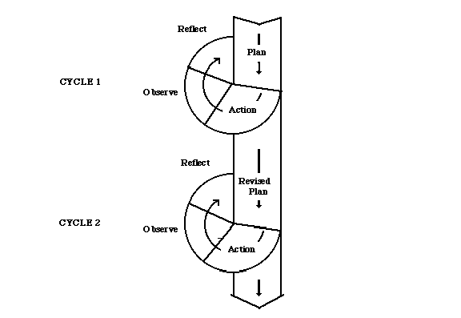
Classroom action research consists of two cycles in which each cycle contains of four phases; planning, action, observation, and reflection. It means a classroom action research should be conducted at least in two cycles. If the results are less satisfactory, researchers can perform the cycle once again in order to achieve the criteria that have been determined. In order to be clear, the researcher presented a model of Action Research stated by Kemmis and Mc Taggart.

Figure 3.1
Kemmis and Mc. Taggart’s Action Research Design
The procedures of research are administrated in two cycles. Each cycle contains of four steps; 1) planning, 2) action, 3) observation, and 4) reflection.
Before the cycle I begins, pre-test was administrated to identify the basic knowledge of the students in speaking skill, the students’ problem in speaking, and students attitude toward English lesson. The pre-test was given to find out the problems of the students in the class during the study.
Planning is an arrangement for doing something. In planning the researcher prepare everything that will be needed in learning process. The following points are the specification of the planning in the first cycle: (1) Deciding the appropriate material and topic, (2) Developing the lesson plan, (3) Preparing the observation sheet for the teacher and the students, (4) Preparing post-test I. Action
Action is process of doing things. It is the implementation of planning. In this step, the students will be taught of how to improve their speaking skill by applying Video Dubbing technique. So the actions are: (1) Presenting some expressions and vocabularies needed, (2) Explaining the instruction for practicing, (3) Applying Video Dubbing, (4) Students perform their Video Dubbing in a record, (5) Evaluating and giving general conclusion.
Observation. In this stage the researcher observes the students’ participation and the students’ achievement. The observer discovers the problem during the teaching and learning process by filling the observation sheet and find out the problems, answering the difficulties of the students in performing the activity.
Reflection is implementing based on the analysis of data from observation and evaluation activities. Reflections is conducting to determine the extent to which media can enhance students speaking skills and to know the advantages and disadvantages of the implementation of learning process which has been implemented in order to avoid recurrence on the second cycle and overcome obstacles that may be encountered on the second cycle.
The cycle will be continued if the results of this study still not reached the minimum mastery criteria, but if the students’ test result was completed the criteria, the cycle will be stopped.
D. Technique of Collecting the Data
1. Speaking test
In collecting the speaking data, the researcher did the speaking test one by one to the students of MAS Amaliyah grade XI-IPA 3 in pre-test and post-test. There are 41 students in this class that consist of 14 males and 27 females. The researcher asked the students a question and they answered it in oral speech. The question was about opinion, the students answered the question and gave their opinion orally. While the students answer the speaking test, the researcher recorded it by handphone. After that, the researcher gave the assessment based on their ability to get their speaking data.
In scoring the data of speaking test, the researcher used the category that evaluates the criteria. There are some criterias that must be considered to assess the students’ speaking skill. The researcher used the speaking skill assessment from Brown H. Douglas.

Table 3.1. English Language Speaking Skills Assessment
Rated Qualities | Points | Behavioral Statements
Pronunciation | 1 | Errors in pronunciation are frequent but can be understood by a native speaker used to dealing with foreigners attempting to speak his language.
 | 2 | Accent is intelligible though often quite faulty.
 | 3 | Errors never interfere with understanding and rarely disturb by native speaker. Accent may be obviously foreign.
 | 4 | Errors in pronunciation are quite rare.
 | 5 | Equivalent to and fully accepted by educated native speakers.
Grammar | 1 | Errors in grammar are frequent, but speaker can be understood by a native speaker used to dealing with foreigners attempting to speak his language
 | 2 | Can usually handle elementary constructions quite accurately but does not have thorough or confident control of the grammar.
 | 3 | Control of grammar is good. Able to speak the language with sufficient structural accuracy to participate effectively in most formal and informal conversations on pratical, social, and professional topics.
 | 4 | Able to use the language accurately on all levels normally pertinent to profesional needs. Errors in grammar are quite rare
 | 5 | Equivalent to that of an educated native speaker.
Vocabulary | 1 | Speaking vocabulary inadequate to express anything but the most elementary needs.
 | 2 | Has speaking vocabulary sufficient to express himself simply with som circumlocutions.
 | 3 | Able to speak the language with sufficient vocabulary to participate effectively in most formal and informal conversations on practical, social, and professional topics. Vocabulary is broad enough that he rarely has to grope for a word.
 | 4 | Can understand and participate in any conversation within the range of his experience with a high degree of precious of vocabulary.
 | 5 | Speech on all levels is fully accepted bu educated native speakers in all its features including breadth of vocabulary and idioms, colloquialisms, and pertinent culturap references/
Fluency | 1 | (No specific fluency description. Refer to other four language areas for implied level of frequency).
 | 2 | Can handle with confident but not with facility most social situations, including interactions and casual conversations about current events, as well as work, family, and aoutobiographical information.
 | 3 | Can discuss particular interest of competence with reasonable ease. Rarely has to grope for words.
 | 4 | Able to use the language fluently on all levels normlaly perminent to professional needs. Can participate in any conversation within the range of this experience with a high degree of fluency.
 | 5 | Has complete fluency in the language such that his speech is fully accepted by educated native speakers.
Comprehension | 1 | Within the scope of his very limited language experience, can understand simple questions and statements if delivered with slowed speech, repetition, or paraphrase.
 | 2 | Can get the gist of most conversations of non-technical subject (i.e., topics that require no specialized knowledge).
 | 3 | Comprehension is quite complete at a normal rate of speech.
 | 4 | Can understand any conversation within the range of his experience.
 | 5 | Equivalent to that of an educated native speaker.

2. Observation
In this case, the researcher used the unstructured observation to get the real condition in teaching learning process. During the observation, the researcher made the observation notes about situation in the class, covers teacher’s performance in teaching speaking and students’ speaking skills (such as; pronunciation, vocabulary, grammar, and their bravery to speak).
3. Interview
Before implementing the research, the researcher interviewed the teacher about students’ difficulties in speaking skill, students’ condition in speaking activity, and the kinds of strategies usually used by the teacher in teaching speaking. The researcher also carried an interview to know the teacher’s response toward the idea of implementing the Video Dubbing technique in improving students’ ability in speaking.
4. Diary Note
Diary note was note for the researcher when the researcher was teaching in the class. It contains about researcher feeling, opinion, estimation, reflection, and explanation. All of it was written in diary note.
5. Documentation
The researcher used a camera to collect all the data. Camera were utilized to record the students’ performance in the teaching and learning process.
E. Technique of Analyzing the Data
This study applied the quantitative and qualitative data. The quantitative data was used to analyze the score of students while the qualitative data was used to describe the situation during on the teaching process. By applying this data, it was assumed to get the satisfying result of the improving ability in speaking through Video Dubbing. The qualitative data was analyzed from the instrument. The quantitative data was analyzed to see the students improvement in speaking. The writer searched the mean of each post-test from every cycle. The writer applied the following formula:
X = $\frac{\sum{X}}{N}$
Where :
X = The mean of the students score.
∑X = The total score.
N = The member of the students.

In order to agglomerate the member of master students, the writer used the following formula:
P = $\frac{R}{T}$ x 100 %
Where:
P = The percentage of students who get the point 75.
R = The number of students who get point up to 75.
T = The total of students who do the test.

CHAPTER IV
RESEARCH FINDING AND DICUSSION
- Research Finding
The data of this study are qualitative and quantitative data. The qualitative data were taken from interviews with teacher and students, observation sheet, and documentation. The quantitative data were taken from students score in some tests. This research was conducted in XI-IPA 3 class with 41 students. This research held in two cycles. Each cycle consisted of four steps of action research (planning, action, observation, and reflection). Before beginning the first cycle, the researcher held pre-test and the researcher gave test as post test I for cycle I and post test II for cycle II in the last meeting of each cycle.

1. The Quantitative Data

a. Pre-Test

The pre-test was conducted at the beginning of the research, on 16 July 2018. The purpose of pre-test was to know the students’ ability in speaking. The pre-test was conducted by speaking test. The researcher asked them about their opinion about bullying and answered it orally. There were 41 students who followed this test.

Table 4.1 Students’ Pre-Test Score
No. | Initial of The Students | Score | Category
1. | AI | 76 | Passed
2. | AP | 80 | Passed
3. | AV | 60 | Failed
4. | AP | 64 | Failed
5. | ASW | 56 | Failed
6. | AA | 48 | Failed
7. | ANL | 64 | Failed
8. | AFH | 72 | Failed
9. | ADA | 76 | Passed
10. | AF | 72 | Failed
11. | DS | 80 | Passed
12. | DA | 56 | Failed
13. | DW | 68 | Failed
14. | DA | 88 | Passed
15. | EDK | 84 | Passed
16. | ESM | 48 | Failed
17. | GR | 56 | Failed
18. | GAP | 48 | Failed
19. | ISS | 48 | Failed
20. | J | 48 | Failed
21. | KNA | 64 | Failed
22. | LAH | 48 | Failed
23. | LMS | 72 | Failed
24. | MS | 48 | Failed
25. | MFS | 72 | Failed
26. | MRP | 56 | Failed
27. | MR | 48 | Failed
28. | MZ | 48 | Failed
29. | PR | 52 | Failed
30. | PS | 76 | Passed
31. | REP | 72 | Failed
32. | RF | 48 | Failed
33. | SA | 80 | Passed
34. | SK | 60 | Failed
35. | SR | 68 | Failed
36. | TN | 76 | Passed
37. | TA | 92 | Passed
38. | T | 84 | Passed
39. | WR | 72 | Failed
40. | WO | 88 | Passed
41. | YC | 72 | Failed
Total |  |  | 2688
Mean |  |  | 65,56

In pre-test, the total score of students was 2688, and the number of students who took the test was 41, the mean of the students’ score was:

X = $\frac{2688}{41}$ = 65,56
The percentage of students speaking skill formulated as below:
P = $\frac{R}{T}$ x 100 %
$P_{1}$ = $\frac{29}{41}$ x 100 % = 70,73 %
$P_{2}$ = $\frac{12}{41}$ x 100 % = 29,26 %
Table 4.2 Percentage of Students’ Speaking skill for Pre Test
 | Category | Number of Students | Percentage
$$P_{1}$$ | Failed | 29 | 70,73 %
$$P_{2}$$ | Passed | 12 | 29,26 %

Based on the result of pre-test, the data showed that the mean score of pre test was 65,56 and there were only twelve or 29,26 % students who passed the Minimum Mastery Criterion – Kriteria Ketuntasan Minimal (KKM). Unfortunately, there were twenty nine students who still got the score under the Minimum Mastery Criterion – Kriteria Ketuntasan Minimal (KKM). The researcher concluded that the students’ speaking skill are still low.

b. Post-Test I

The researcher gave test in post-test I, the test was given after applied Video Dubbing technique. The researcher found improvement of the students’ score in post-test of the first cycle.
Table 4.3. Students’ Post-Test I Score
No. | Initial of The Students | Score | Category
1. | AI | 76 | Passed
2. | AP | 80 | Passed
3. | AV | 64 | Failed
4. | AP | 68 | Failed
5. | ASW | 60 | Failed
6. | AA | 64 | Failed
7. | ANL | 68 | Failed
8. | AFH | 76 | Passed
9. | ADA | 76 | Passed
10. | AF | 76 | Passed
11. | DS | 80 | Passed
12. | DA | 68 | Failed
13. | DW | 72 | Failed
14. | DA | 88 | Passed
15. | EDK | 84 | Passed
16. | ESM | 64 | Failed
17. | GR | 60 | Failed
18. | GAP | 60 | Failed
19. | ISS | 60 | Failed
20. | J | 60 | Failed
21. | KNA | 68 | Failed
22. | LAH | 60 | Failed
23. | LMS | 76 | Passed
24. | MS | 64 | Failed
25. | MFS | 76 | Passed
26. | MRP | 64 | Failed
27. | MR | 64 | Failed
28. | MZ | 64 | Failed
29. | PR | 68 | Failed
30. | PS | 76 | Passed
31. | REP | 76 | Passed
32. | RF | 68 | Failed
33. | SA | 80 | Passed
34. | SK | 64 | Failed
35. | SR | 68 | Failed
36. | TN | 76 | Passed
37. | TA | 92 | Passed
38. | T | 84 | Passed
39. | WR | 72 | Failed
40. | WO | 88 | Passed
41. | YC | 76 | Passed
Total |  |  | 2928
Mean |  |  | 71,41

In post-test, the total score of students was 2928 and the number of students who took the test was 41, the mean of the students’ score was:

X = $\frac{2928}{41}$ = 71,41
From the table above, it can be seen that students’ speaking skill already improved, but the success criteria still could not reach. To know the student’ who were competent was calculated by applying the formula below:
P = $\frac{R}{T}$ x 100 %
$P_{1}$ = $\frac{23}{41}$ x 100 % = 56,09 %
$P_{2}$ = $\frac{18}{41}$ x 100 % = 43,90 %

Table 4.4.Percentage of Students’ Speaking skill for Post Test I
 | Category | Number of Students | Percentage
$$P_{1}$$ | Failed | 23 | 56,09 %
$$P_{2}$$ | Passed | 18 | 43,90 %

The result of the post test of the first cycle, the mean score was 71,41 and there were eighteen students or 43,90 % of students who passed the KKM. There is students’ improvement in speaking skill between pre-test and post-test I after being tought by video dubbing technique.

C. Post-Test II

The researcher choose to continue the research in cycle two. The aim was to improve the students’ score in speaking after doing post-test in the first cycle.

Table 4.5. Students’ Post-Test II Score
No. | Initial of The Students | Score | Category
1. | AI | 80 | Passed
2. | AP | 80 | Passed
3. | AV | 76 | Passed
4. | AP | 76 | Passed
5. | ASW | 68 | Failed
6. | AA | 76 | Passed
7. | ANL | 76 | Passed
8. | AFH | 80 | Passed
9. | ADA | 76 | Passed
10. | AF | 76 | Passed
11. | DS | 84 | Passed
12. | DA | 76 | Passed
13. | DW | 80 | Passed
14. | DA | 88 | Passed
15. | EDK | 84 | Passed
16. | ESM | 76 | Passed
17. | GR | 64 | Failed
18. | GAP | 64 | Failed
19. | ISS | 68 | Failed
20. | J | 64 | Failed
21. | KNA | 76 | Passed
22. | LAH | 64 | Failed
23. | LMS | 80 | Passed
24. | MS | 76 | Passed
25. | MFS | 80 | Passed
26. | MRP | 76 | Passed
27. | MR | 76 | Passed
28. | MZ | 76 | Passed
29. | PR | 76 | Passed
30. | PS | 80 | Passed
31. | REP | 80 | Passed
32. | RF | 68 | Failed
33. | SA | 80 | Passed
34. | SK | 68 | Failed
35. | SR | 68 | Failed
36. | TN | 76 | Passed
37. | TA | 92 | Passed
38. | T | 84 | Passed
39. | WR | 76 | Passed
40. | WO | 88 | Passed
41. | YC | 76 | Passed
Total |  |  | 3128
Mean |  |  | 76,29

In post-test II, the total score of students was 3128 and the number of students who took the test was 41, the mean of the students’ score was:

X = $\frac{3128}{41}$ = 76,29
From the table above, students’ speaking skill in English lesson was good. The mean of students was 76,29. To know the student’ who were competent was calculated by applying the formula below:
P = $\frac{R}{T}$ x 100 %
$P_{1}$ = $\frac{9}{41}$ x 100 % = 21,95 %
$P_{2}$ = $\frac{32}{41}$ x 100 % = 78,04 %
Table 4.6.Percentage of Students’ Speaking skill for Post Test II
 | Category | Number of Students | Percentage
$$P_{1}$$ | Failed | 9 | 21,95 %
$$P_{2}$$ | Passed | 32 | 78,04 %

The result of the post test of the second cycle, the mean score was 76,29 and there were thirty two students or 78,04 % of students who passed the KKM. It is indicated that the research is successful and the researcher stopped the research in this cycle.
2. The Qualitative Data
a. Cycle I
1. Planning
In this phase, the researcher and the teacher made a planning based on the problems faced by students in speaking skill. In this case, the researcher arranged a lesson plan based on the teaching material. Beside of making the lesson plan, the researcher also prepared observation sheet to observe the students and teacher’s performances during the teaching learning process. The researcher also prepared the post-test I to collect the data in order to know the students’ improvement after the application of the technique.
2. Action
The action of the cycle I was done on 18 July 2018. In action phase, the teacher implemented a lesson plan that had been made before. In this phase, the researcher implemented video dubbing the technique to teach. First, the researcher introduced the material by giving example of giving opinion in the video. Second, the researcher explained to the students about the giving opinion. Third, the researcher divided the students into group of 5 and every group discuss and arrange a new scenario. Next, the students present their new scenario in giving opinion. Then, researcher gave feedback to students after finishing their performance. The last step, the students dub their new scenario into the muted video. The researcher gave general conclusion which is about material in the end of class.
In the second meeting, the researcher gave the post-test I in the end of cycle I. The test was about giving opinion. The post-test I was held to measure the improvement of students’ speaking ability after the application of video dubbing technique.
3. Observation
The observer tried to notice all activities in the physical classroom activity. It might be about the teachers’ performance, students’ response and students’ participations during teaching and learning process by using video dubbing technique.
In this phase, related to the observation sheet for the teacher, the teacher didn’t deliver the material by combining the native and target language. Moreover, the teacher responded the students’ participation in a form reaction.
Second, related to the students’ response, the students did not participate in the learning process. The students didn’t discuss to make a new scenario of video with their group. Moreover, they made some noise while the other students performed and the teacher explained the material in the front of the class. However, the teaching and learning activity happened enthusiastically.
Third, the students showed some progress in the learning process than before implementing video dubbing technique. Their pronunciation, grammar, vocabulary, and fluency were better than before the implementation of video dubbing technique. The observation sheet can be seen in Appendix IX (page 74-75).
4. Reflection
The researcher and the teacher evaluated the conclusion of implementing the action based on the result of post-test I. Eventhough, there was improvement of students speaking skill, the research success criteria had not reached yet. Then, the researcher and the teacher tried to modify the action in order 75% of students in the class could pass the KKM. Moreover, the students seemed to accept the material easily by implementing video dubbing technique. From the reflecting phase above, there were some improvement that would be implement in the cycle II.

b. Cycle II

1. Planning

After finding the fact that the students’ could not reach the success criteria which was proven by students’ post-test I scores. Then, the researcher and the teacher rearranged the lesson plan which was used in the previous cycle with some modifications. The teacher and the researcher made a lesson plan that can gave the chance for the teacher explain more about the material. Beside of that, the researcher also prepared the observation sheet to note the classroom activities and the post-test 2 to collect the data.

2. Action

The action of cycle two was done on 25 July 2018. In this meeting, the teacher asked the students about their difficulties in implementing video dubbing technique in learning speaking. In this meeting, the researcher made some modifications in teaching the students based on the lesson plan. The researcher devided the students into the same groups like the last meeting. The researcher gave the more explanations about giving opinion. The researcher also helped the students with the grammar and the vocabularies that they needed. Next, the students present their new scenario in giving opinion. Then, researcher gave feedback to students after finishing their performance. The last step, the students dub their new scenario into the muted video. The researcher gave general conclusion which is about material in the end of class.

In the second meeting, the researcher gave the post-test 2. It was oral test and the test about giving opinion.

3. Observation

The observer tried to notice all activities in the physical classroom activity. It might be about the teachers’ performance, students’ response and students’ participations during teaching and learning process by using video dubbing technique.

In this phase, related to the observation sheet for the teacher, the teacher delivered the material by combine the native and target language. Moreover, the teacher responded the students’ participation in a form reaction.

Second, related to the students’ response during teaching and learning activity, most of students paid attenttion to the teacher explanation and practice with their pairs enthusiastically.

Third, related to the students’ participation, it showed some progress than in the cycle I. Most students participated in class conversations, discussions, and performances. Their pronunciation, grammar, vocabulary, and fluency were better than before. The observation sheet can be seen in Appendix X (page 76-77).

4. Reflection

The teacher and the researcher analyzed the result of cycle II. Most of the students responded the teacher actively. Furthermore, the teaching learning process was done very well. The research stopped in this cycle because the students had significant improvement from the score get from pre-test, post-test I and post-test II and the research target reached, which 75% students passed the KKM.

B. Discussion

This research was conducted to find out the improving of the students’ speaking skill by applyingvideo dubbing. The video dubbing technique is one of the technique that could be used by the teacher in teaching speaking.

The research that had been done by the researcher indicated that video dubbing was effective in teaching speaking. It could be seen from the tables that showed the increasing of students’ score from pre-test, post test I, and post test II. The improvement of the students ability was the teacher could control the class and created the active class. The technique also helped the students be more active to practice their speaking and indirectly, increase the students ability in speaking.

Table 4.7. Percentage of Students’ Speaking Skill
Name of Test | Number of the Students who Got the Score ≥75 | Percentage
Pre test | 12 | 29,26 %
Post test I | 18 | 43,90 %
Post test II | 32 | 78,04 %

Based on the data above, the result showed the improvement of the students’ scores from the pre-test to the post-test of cycle I. In the pre-test, the students who got the score 75 or more were twelve of forty one students (29,26%). In the post-test I, students who got the score 75 or more were eighteen of forty one students students (43,90%). In the post-test II, students who got the score 75 or more were thirty two of forty one students (78,04%).

The quantitative data above was also strengthened by the qualitative data taken through interview. Interview was also done when the researcher implementing the technique to the students. The students interested in the way of learning speaking. They felt more enthusiastic and enjoy because the use of technology in the learning process. On the other hand, they were also happy because they could practice their speaking skill. The transcript of interview can be seen in Appendix VIII (page 71).

So, it can be concluded that the result of the research showed that the implementation of video dubbing technique improved the students’ ability in speaking. It can be seen from the quantitative data proven by the students’ score got better in the post test I than the pre-test, and the post-test II got better than the post-test I. Based on qualitative data, it was found that the class ran effectively.

CHAPTER V
CONCLUSION AND SUGGESTION
A. Conclusion
Based on the result of data analysis, the researcher concluded that teaching speaking by applying video dubbing technique can improve students’ speaking ability. It can be proved through several data such as; pre-test and post-test. The result of pre-test shows that the students’ mean score is only 65,56, and in post-test I, the students’ mean score is 71,41, and in post-test II the students’ mean score is 76,29 with 78,04 % students who passed the KKM, so it was shows the significant improvement in teaching speaking by video dubbing technique. Moreover by implementing video dubbing technique in teaching speaking, the students have chance to be active and cooperative in speaking activity. It is showed by the increasing of students’ participations in the class based on the qualitative data.
B. Suggestion
Based on the result of this research, the researcher give suggestions:
- For the Headmaster
The headmaster can suggest to their English teacher to use this technique in teaching speaking because the result of this research show that video dubbing technique can improve students’ ability in speaking.
- For the English Teacher
It is better for the English teacher to apply video dubbing technique in teaching speaking because it can improve the students’ speaking skill.

- For the Students
The students are expected to improve their speaking because speaking is the important skill.
- For the Researchers
For the further researcher can consider video dubbing technique to conduct the research.
- For the Readers
For the reader, this research can be a reference for the new research or it can be an idea to apply video dubbing technique in teaching learning process.
REFERENCES

Adella Purnama Sari, ʺThe Implementation of U-Shape Debate Strategy to Improve Students' Ability at Speaking at MAS Al-Jamiyatul Washliyah 22 Tembungʺ, skripsi. Medan: the Degree of Sarjana Pendidikan State Islamic University of North Sumatera, 2013.

Anonymous, Define Dubbing at Dictionary.com. accessed from www.dictionary.com/browse/dubbing. on April 10, 2018.

Anonymous, define skill at Business Dictionary, accessed from http://www.businessdictionary.com/definition/skill.html, on August 1, 2018.

Anonymous, define skill at Wikipedia, accessed from https://en.wikipedia.org/wiki/Skill, on August 1, 2018

Anonymous, define skill Merriam-Webster, accessed from https://www.merriam- webster.com/dictionary/skill, on August 1, 2018

Arikunto, Suharsimi. 2009. Penelitian Tindakan Kelas. Jakarta: BumiAksara.

Brown, H. Douglas. 2004. Language Assessment: Principles and Classroom Practices. New York: Pearson Education.

Burston, Jack. Video Dubbing Projects in the Foreign Language Curriculum. CALICO Journal. 23 (1): 79-92.

Cakir, I. 2006. The use of video as an audio-visual material in foreign language teaching classroom. The Turkish Online Journal of Educational Technology-TOJET. 5 (4).

Chiu, Yi-Hui. 2012. Can Film Dubbing Projects Facilitate EFL Learners’ Acquisition of English Pronunciation.British Journal of Educational Tecnnology. 43 (1): 24-27.

Daniel, Andrea, 2010, Perception Gaps between Headquarters and Subsidiary Managers: Differing Perspectives on Subsidiary Roles and Their Implications, Wiesbaden: Gabler

Delahunty, Gerald P. and Garvey, James J., 2010, The English Language from Sound to Sense, USA: Parlor Press.

Fulcher, Glenn. 2003. Testing Second Languge Teaching. London: Longman.

Ghory,M. Djuanaidi. 2008.PenelitianTindakanKelas. Malang: UIN Malang Press.

Haidir & Salim, 2014, Strategi Pembelajaran, Medan: Perdana Publishing.

Harmer, Jeremy. 2007. The Practice of English Language Teaching: Fourth Edition. Harlow: Pearson Education Limited.
Jolliffe, Wendy. 2007. Cooperative Learning in the Classroom Putting it into Practice, UK: Paul Chapman Publishing.

Kayi,Hayriye. 2006. Teaching speaking: Activities to Promote Speaking in a Second Language. The Internet TESL Journal. 12 (11). Retrieved from http://iteslj.org/Articles/Kayi-TeachingSpeaking. html.

Maxom, Michelle. 2009. Teaching English as a Foreign Language for Dummies. West Sussex: John Willey & Sons.

McDonough, Jo and Christopher Shaw. 2003. Materials and Methods in ELT: Second Edition A Teacher’s Guide. Oxford: Blackwell Publishing.

Mike. 2017. What is Dubbing? accessed from mikemigas.com/26653, on April 10, 2018.

Muniandy, B. And Veloo,S. 2011. Managing and Utilizing Online Video Clips for Teaching English Language: Views of TESOL Pre Service Teachers. Singapore: IACSIT Press.

Nunan, D. & Carter, R. 2001. The Cambridge Giude to Teaching English to Speakers of Other Languages. Cambridge: Cambridge University Press.

Nuryandi, Sanda, et.al. 2017. Efektivitas Penggunaan Dubbing Film untuk Meningkatkan Kemampuan Berbicara. EDUJAPAN. 1 (1): 43-53.

Rahmawati, Sherly and Amri, Zul. 2013. Using the Lost Twin Game to Improve Pronunciation of Junior High School Student. Journal of English Language Teaching. 1 (2): 556-564.

Richards, Jack C. and Renandya,Willy A. 2002. Methodology in Language Teaching: An Anthology of Current Practice. USA: Cambridge University Press.

Rickheit, Gert and Strohner, Hans. 2008. Handbook of Communication Competence. Germany: De Gruyter Mouton.

Rizki Mutiara, about “Improving Students’ Speaking Achievement Through Realia”, skripsi. Medan : English Literature of UNIMED, 2011.

Santoso, Didik, 2008, Pengaruh Pendekatan Pembelajaran dan Gaya Belajar terhadap Keterampilan Berbicara Bahasa Inggris, Medan: Duta Azhar.

Sopinabila Br. Karo, “The Implementation of Humor Teaching English Material to Improve Students’ Achievement in Speaking at Grade of XI of Madrasah Aliyah Darul Azhar Kutacane”, skripsi. Medan: the Degree of Sarjana Pendidikan State Islamic University of North Sumatera, 2016.

Sudijono, Anas. 2014. Pengantar Statistik Pendidikan. Jakarta: Raja Grafindo Persada.
Tomgodfrey, 2010, Drama in English Language Teaching: A Whole-Person Learning Approach, accessed on April 4, 2018 at 12.59 am (https://tomgodfrey.wordpress.com/2010/08/15/drama-in-english-language-reaching-a-whole-person-learning-approach/)

Tran, Van Dat. 2013. Theoretical Prespective Underlying the Application of Cooperative Learning in Classroom. International Journal of Higer Education. 2 (4): 101-115.

Turk, C. 2003. Effective Speaking: Communicating in Speech. London: Spon Press.

APPENDICES
APPENDIX 1
LESSON PLAN
School : MAS. Amaliyah
Class/Semester : XI-IPA 3/1
Subject/Skill : English/ Speaking
Topic : Giving Expressions
Time Duration : 2 x 45 minutes
Meeting : 1stmeeting

Standar Competency:
Using transactional meaning in text conversations and formal interpersonal and continues (sustained) in the context of daily activity.
Basic Competency :
Expressing meaning in a conversation transactional (to get things done) and interpersonal (social) and the official continues (sustained) by using a variety of spoken language accurately, fluently and acceptable in the context of daily life and engage said: expressions of giving advice and giving opinion.
Indicators :
Students are able to:
- Identify the expressions of giving advice.
- Have accurate pronunciation in using the expressions of giving advice.
- Have accurate intonation in using the expressions of giving advice.
- Use the expressions of giving advice based on the situation.
- Do a discussion in a group to make the new arrangement of video dubbing using the expression of giving advice.
- Perform video dubbing by group in front of the class.
Learning Objectives :
By the end of the lesson, the students are able to express the meaning and to say the sentences for giving advice accurately, fluently and acceptably. Also students can ask/give opinion with appropriate utterances.
Source :
1. Internet
2. English book of XI class
Media :
Video Dubbing and dictionary.
Materials :
- Expressions of giving advice
- Why don’t you...
- What about...
- You should...
- You can...
- Do you need...?
In a short conversation
- Researcher : what is your advice if your friend is comming late?
Student : you should get up early
Student : don’t sleep in the late night
Student : please go my motocycle
- Researcher : what is your advice if your brother’s hobby is climbing the mountain?
Student : brother, you should becarefull and always bring your climbing equipment and don’t forget to always do the prayer.
- Researcher : what is your advice if your sister will going to do the national examination?
Student : do the prayer before doing the exam
Student : don’t make a noice while doing the exam
Student : bring your own exam equipment
- Reasercher : what is your advice if the person that you love will
go to the other city for long time?
Student : keep your healthy
Student : always remember me
Student : do the pray all time
- Researcher : what is your advice to your friend that can see something that you can’t see
Student : always remember Allah
Student : don’t let your brain emty
- Researcher : what is your advice if your friend will go to his/her musical show?
Student : don’t be shy
Student : do as what you can do
Student : if the music is off in the middle of show, you should continue the show.

Topic to discuss in a group discussion :
Making a dub of video using these genre:
- Nature
- Adventure
- Family
- Romance
- Thriller
- Musical

Method :
PPP (Presentation, Practice, Production)

Learning Activities :
No | Activities |  | Duration
 | Researcher | Students
Pre-Teaching |  |  | 15 minutes
1 | Starting the lesson by greeting and saying a prayer. | Answering the greeting from the researcher and saying a prayer.
2 | Checking the students attandance and asks the students’ condition. | Answering the students’ attandance from the researcher and saying their conditions to the researcher.
3 | Warming up the students by giving some question about the topic that will be discussed in the class. | Answering the questions given by the researcher.
4 | Motivating the students for learning seriously. | Feeling motivated and excited to learn seriously.
5 | Introducing the topic of what they are going to learn today. | Listening to the introduction of the subject that provided by the researcher.
Whilst-Teaching |  |  | 70 minutes
6 | Writing the question on the board. | Answering the question that written on the board.
7 | Choosing which question and answer the class like best. | Giving their best answer.
8 | Dividing each student to a small group. | Siting in their group.
9 | Write down the title of video for each group and ask them to arrange the new scenario. | Listening on the teacher’s description.
10 | Assigning the students to make a perform of role-play. | Making a perform of role-play.
11 | Giving the sudents 10-15 minutes to work in their group. | Working in their group.
12 | Watching the student’s presentation. | Presenting their presentation.
Post-Teaching |  |  | 5 minutes
13 | Giving feedback. | Listen the feedback from the researcher.
14 | Taking a conclusion of what they are learning today. | Taking a conclusion of what they are learning today.
 |  | Understaning about the topic that they have learned.
15 | Ending the lesson and saying a prayer. | Feeling that video dubbing is good to apply in speaking class.
 |  | Saying prayer.

Assessment :
- Form : Oral production
- Techniques : Group discussion
- Rubric :

Rated Qualities | Points | Behavioral Statements
Pronunciation | 1 | Errors in pronunciation are frequent but can be understood by a native speaker used to dealing with foreigners attempting to speak his language.
 | 2 | Accent is intelligible though often quite faulty.
 | 3 | Errors never interfere with understanding and rarely disturb by native speaker. Accent may be obviously foreign.
 | 4 | Errors in pronunciation are quite rare.
 | 5 | Equivalent to and fully accepted by educated native speakers.
Grammar | 1 | Errors in grammar are frequent, but speaker can be understood by a native speaker used to dealing with foreigners attempting to speak his language
 | 2 | Can usually handle elementary constructions quite accurately but does not have thorough or confident control of the grammar.
 | 3 | Control of grammar is good. Able to speak the language with sufficient structural accuracy to participate effectively in most formal and informal conversations on pratical, social, and professional topics.
 | 4 | Able to use the language accurately on all levels normally pertinent to profesional needs. Errors in grammar are quite rare
 | 5 | Equivalent to that of an educated native speaker.
Vocabulary | 1 | Speaking vocabulary inadequate to express anything but the most elementary needs.
 | 2 | Has speaking vocabulary sufficient to express himself simply with som circumlocutions.
 | 3 | Able to speak the language with sufficient vocabulary to participate effectively in most formal and informal conversations on practical, social, and professional topics. Vocabulary is broad enough that he rarely has to grope for a word.
 | 4 | Can understand and participate in any conversation within the range of his experience with a high degree of precious of vocabulary.
 | 5 | Speech on all levels is fully accepted bu educated native speakers in all its features including breadth of vocabulary and idioms, colloquialisms, and pertinent culturap references/
Fluency | 1 | (No specific fluency description. Refer to other four language areas for implied level of frequency).
 | 2 | Can handle with confident but not with facility most social situations, including interactions and casual conversations about current events, as well as work, family, and aoutobiographical information.
 | 3 | Can discuss particular interest of competence with reasonable ease. Rarely has to grope for words.
 | 4 | Able to use the language fluently on all levels normlaly perminent to professional needs. Can participate in any conversation within the range of this experience with a high degree of fluency.
 | 5 | Has complete fluency in the language such that his speech is fully accepted by educated native speakers.
Comprehension | 1 | Within the scope of his very limited language experience, can understand simple questions and statements if delivered with slowed speech, repetition, or paraphrase.
 | 2 | Can get the gist of most conversations of non-technical subject (i.e., topics that require no specialized knowledge).
 | 3 | Comprehension is quite complete at a normal rate of speech.
 | 4 | Can understand any conversation within the range of his experience.
 | 5 | Equivalent to that of an educated native speaker.

Total skor : 5x5 = 25
Nilai : total skor x 4 = 100

Sunggal, Agustus 2018

Head Master English Teacher

Jufri Effendi, S.Pd,I., M.Pd Ammad Japar, S.Pd

Researcher

Kiki Amalia

APPENDIX II

LESSON PLAN
School : MAS. Amaliyah
Class/Semester : XI-IPA 3/ 1
Subject/Skill : English/ Speaking
Topic : Giving Expressions
Time Duration : 2 x 45 minutes
Meeting : 2nd meeting

Standard Competency:
Using transactional meaning in text conversations and formal interpersonal and continues (sustained) in the context of daily activity.
Basic Competency :
Expressing meaning in a conversation transactional (to get things done) and interpersonal (social) and the official continues (sustained) by using a variety of spoken language accurately, fluently and acceptable in the context of daily life and engage said: expressions of hope.
Indicators :
Students are able to :
- Identify the expression of asking for opinion giving opinion.
- Have accurate pronunciation in using the expression of asking for opinion giving opinion.
- Have accurate intonation in using the expressions of asking for opinion and giving opinion.
- Use the expressions of asking for opinion and giving opinion based on the situation.
- Do a discussion in a group to make the script of video dubbing using the expression of asking for opinion and giving opinion.
- perform video dubbing by group in front of the class.
Learning Objectives :
By the end of the lesson, the students are able to express the meaning of asking/ giving opinion accurately, fluently and acceptably. Also students can ask/give opinion with appropriate utterances.
Source :
1. Internet
2. English book of XI class
Media :
Video dubbing and dictionary.
Materials :
Expressions of opinion
- I think...
- I suppose...
- In my opinion...
- Researcher : What is your opinion if your friend is doing some homework in the class.
Student : I think she or he is do not understand with the homowork.
Student :In my opinion she is lazy.
- Researcher : What is your opinion if you have a long holliday?
Student : I think I will go to Sibayak mountain
Student : in my opinion I will go to Aceh
- Researcher : What is your opinion if you see your father is came home from work?
Student : I think he is very tired
Student : I think I will make a glass of tea
- Researcher : What is your opinion if you have someone that you love and you do not want to lose him/her?
Student : I think I will always make him/her happy
- Researcher : What is your opinion if you watch the thriller movie?
Student : I think the thriller movie is not too scary
- Researcher : What is your opinion if you are in the musical show, than the music is off in the middle of show?
Student : I think I will continue the show
Topic to discuss in a group discussion:
Making the script from the short theatre using these genre:
- Nature
- Advanture
- Family
- Romance
- Thriller
- Musical
Method :
- PPP (Presentation, Practice, Production)

Learning Activities :
No | Activities |  | Duration
 | Researcher | Students
Pre-Teaching |  |  | 15 minutes
1 | Starting the lesson by greeting and saying a prayer. | Answering the greeting from the researcher and saying a prayer.
2 | Checking the students attandance and asks the students’ condition. | Answering the students’ attandance from the researcher and saying their conditions to the researcher.
3 | Warming up the students by giving some question about the topic that will be discussed in the class. | Answering the questions given by the researcher.
4 | Motivating the students for learning seriously. | Feeling motivated and excited to learn seriously.
5 | Introducing the topic of what they are going to learn today. | Listening to the introduction of the subject that provided by the researcher.
Whilst-Teaching |  |  | 70 minutes
6 | Writing the question on the board. | Answering the question that written on the board.
7 | Choosing which question and answer the class like best. | Giving their best answer.
8 | Dividing each student to a small group. | Siting in their group.
9 | Write down the title of video for each group and ask them to arrange the new scenario. | Listening on the teacher’s description.
10 | Assigning the students to make a perform of role-play. | Making a perform of role-play.
11 | Giving the sudents 10-15 minutes to work in their group. | Working in their group.
12 | Watching the student’s presentation. | Presenting their presentation.
Post-Teaching |  |  | 5 minutes
13 | Giving feedback. | Listen the feedback from the researcher.
14 | Taking a conclusion of what they are learning today. | Taking a conclusion of what they are learning today.
 |  | Understaning about the topic that they have learned.
15 | Ending the lesson and saying a prayer. | Feeling that mystery theatre game is good to apply in speaking class.
 |  | Saying prayer.
Assessment :
- Form : Oral production
- Techniques : Group discussion
- Rubric :
Rated Qualities | Points | Behavioral Statements
Pronunciation | 1 | Errors in pronunciation are frequent but can be understood by a native speaker used to dealing with foreigners attempting to speak his language.
 | 2 | Accent is intelligible though often quite faulty.
 | 3 | Errors never interfere with understanding and rarely disturb by native speaker. Accent may be obviously foreign.
 | 4 | Errors in pronunciation are quite rare.
 | 5 | Equivalent to and fully accepted by educated native speakers.
Grammar | 1 | Errors in grammar are frequent, but speaker can be understood by a native speaker used to dealing with foreigners attempting to speak his language
 | 2 | Can usually handle elementary constructions quite accurately but does not have thorough or confident control of the grammar.
 | 3 | Control of grammar is good. Able to speak the language with sufficient structural accuracy to participate effectively in most formal and informal conversations on pratical, social, and professional topics.
 | 4 | Able to use the language accurately on all levels normally pertinent to profesional needs. Errors in grammar are quite rare
 | 5 | Equivalent to that of an educated native speaker.
Vocabulary | 1 | Speaking vocabulary inadequate to express anything but the most elementary needs.
 | 2 | Has speaking vocabulary sufficient to express himself simply with som circumlocutions.
 | 3 | Able to speak the language with sufficient vocabulary to participate effectively in most formal and informal conversations on practical, social, and professional topics. Vocabulary is broad enough that he rarely has to grope for a word.
 | 4 | Can understand and participate in any conversation within the range of his experience with a high degree of precious of vocabulary.
 | 5 | Speech on all levels is fully accepted bu educated native speakers in all its features including breadth of vocabulary and idioms, colloquialisms, and pertinent culturap references/
Fluency | 1 | (No specific fluency description. Refer to other four language areas for implied level of frequency).
 | 2 | Can handle with confident but not with facility most social situations, including interactions and casual conversations about current events, as well as work, family, and aoutobiographical information.
 | 3 | Can discuss particular interest of competence with reasonable ease. Rarely has to grope for words.
 | 4 | Able to use the language fluently on all levels normlaly perminent to professional needs. Can participate in any conversation within the range of this experience with a high degree of fluency.
 | 5 | Has complete fluency in the language such that his speech is fully accepted by educated native speakers.
Comprehension | 1 | Within the scope of his very limited language experience, can understand simple questions and statements if delivered with slowed speech, repetition, or paraphrase.
 | 2 | Can get the gist of most conversations of non-technical subject (i.e., topics that require no specialized knowledge).
 | 3 | Comprehension is quite complete at a normal rate of speech.
 | 4 | Can understand any conversation within the range of his experience.
 | 5 | Equivalent to that of an educated native speaker.

Total skor : 5x5 = 25
Nilai : total skor x 4 = 100
Sunggal, Agustus 2018

Head Master English Teacher

Jufri Effendi, S.Pd,I., M.Pd Ammad Japar, S.Pd

Researcher

Kiki Amalia

Appendix III
Instrument of Pre-Test and Post Test I
Speaking Test
There are several steps in speaking test:
- In this speaking test there is one question that will be asked, that is: “What is your opinion about bullying?”
- The students answer the question orally.
- The answers will be recorded by phone.
4. There is some possebilitieis for the answer such as: “my opinion about bullying is a bad act. It is a horrible thing to do. I think that the people who bully other poeople are just insecure and want to show that he/she is not weaker than others. There should be serious measures when someone is getting bullied and if you tell to someone, they should await severe punishment so that the bullying would stop.”
Appendix IV
Students’ Transcripts of Pre-Test and Post-Test I
Pre-Test Transcript
1. AI
I think bullying is bad because bullying have negative impact like like like like down mental and more.
2. DA
I think bullying is not good because, honestly I get a bully in my junior high school and it makes my mental down like you tell your parents but they still bullying me and it is you know. The demage of the bully is still in my body.
3. TN
I think bullying is a, wait...about bullying, I think Bullying is a bad attitude that can makes kid or a person get a trauma or something like that.
Post Test I
1. AI
I think bullying is a such bad behavior. Bullying is a very shameful act, we can not work with a bully person.
2. DA
What do I think about bullying? I think a bullying is not good. Why? Taking fun from another people by doing some violence things and it means that a just disobligate the meaning of human right. Means that human have the same right and orders polite that, bulying you know it is very often happen in teenagers and more like students high school something. But the point is for me in my opinion. Bullying is not good. It’ not really good because you just disobligate the human right and the meaning of the same, which human has the same pointand there is such differentiation between them. Thank you.
3. TN
Bullying is an action that cannot be replicate because bully can cause a person to traumatized by the action of others. Bully by physically can hurt someone.

Appendix V
Instrument of Post Test II
Speaking Test
There are several steps in speaking test:
1. In this speaking test there is one question that will be asked, that is: “What is your opinion about drugs?”
2. The students answer the question orally.
3. The answers will be recorded by phone.
4. There is some possibilities for the answer such as: “my opinion about drugs is very dangerous and not good for health. Drugs can lead to serious injuries, illness, and even death. Drugs sometime needed for medicine but with right utility”

Appendix VI
Students’ Transcripts of Post-Test II
1. AI
For me drugs have negative impact like problem at school, problem with yourself and even losing your world, so drugs is very very bad.
2. DA
In my point of view, drugs are a part of medicines which is related to a medical, medical technique and what do I think here about drugs, when you hear about drugs. You may think like that a potion and also not good for health but the point here, the point is not to over use or do make usage become overdose. As the doctor or someone else give you the recipe and yeah the point is that you, you must use not too much just for the additional perpose just like to heal you as patient. Thank you.
3. TN
I think drugs is a medicine that can ruin out body, our brain and our healthiness and it can kill us. Don’t try to use drugs because it makes us addicted to it.

Appendix VII
TEACHER’S INTERVIEW TRANSCRIPT
Pre-test
R : Saya ingin menanyakan sesuatu, bagaimana kemampuan bahasa inggris kelas yang akan saya teliti Sir?
T : Untuk yang akan diteliti kelasnya, sebenarnya untuk kemampuan anak-anak itu kita anggap sudah lumayan tapi menurut saya 50 : 50 laa untuk vocabulary nya.
R : Dalam mengajar bahasa Inggris sama mereka Sir apa aja kendala yang Sir hadapi? Ataukah kurang vocabnya, ataukah gatau grammar, atau gimana Sir?
T : Eee yang pertama itu, yang first nya vocabulary. Sometime itu kalau anak-anak itu disuruh bawa kamus, kadang ada aja itu satu satu dua orang yang gak bawa. Itu kesulitannya. Mungkin dimanapun, disetiap kelas pasti ada satu satu yg gak bawa. Kan saya pernah bilang sama anak-anak, someone itu can speak English, gitukan, bisa bahasa Inggris, impossible tidak bawa dictionary. Saya bilang seperti itu.
R : Menurut Sir, ada nggak hubungan minat belajar orang itu dengan kreatifitas sir dalam mengajar mereka? Misalnya sir menggunakan game atau ..
T : technik? Ee ada, kadang- kadang saya mix juga. Kadang saya kasi pembelajaran dengan tekhnik game, mereka senang mengikuti pelajaran saya, kemudian saya mix language bahasa Inggris itu dari bahasa inggris itu kebahasa daerah. Mereka senang. Contohnya, for example : kamu kan orang jawa, lurus jadinya belok. Kadang-kadang saya bilang takjiah, bahasa jawa nya kan tukem. Sebenarnya itu bahasa inggris to come tapi jawa bilangnya tukem. Artinya datang. Seperti itu di mix.
R : terakhir sir, apa masalah utama mereka dalam belajar bahasa inggris sir?
T : masalah utamanya, not confidence. Tidak percaya diri. Itu aja sebenarnya. Yah intinya not confidence lah, kalau misalnya .. nggak semua yg confidence. Some of students lah, nggak the most. Kadang mereka bisa, saya coba teknik yang lain bisa. Mereka ketawa gitu kan, mungkin karena bahasa asing
R : kalau dalam speaking nya sir apa masalah utamanya?
T : yang pertama about pronunciation; padahal sudah cukup sering saya sampaikan kepada mereka. Record.. record.. dan record. Mau saya suruh bawa yg oxford itukan mungkin tarafnya gabisa. Tapi saya sampaikan, kalau gdak oxford pakai kamus di handphone kan bisa. Aktifkan voice nya kan bisa melatih pronunciationnya.
R : oke sir, thank you
T : thank you
Post test 1
R : menurut sir apakah ada peningkatan kemampuan bahsa inggris siswa setelah saya menerapkan teknik saya yaitu video dubbing sir?
T : kalau masih disini, perkembangannya sudah ada tapi masih perlu ditingkatkan lagi ke tahap-tahap selanjutnya.
R : ketika saya menerapkan teknik saya, apakah mereka tertarik dalam pembelajarannya?
T : not the most of the student, sebagian siswanya interets. Itulah, perlu dilanjutkan lagi ke cycle berikutnya supaya mendapatkan hasil perfect lah
Post test 2
R : setelah saya menerapkan lagi teknik saya dalam mengajar bahsa inggris ini sir, apakah speaking mereka lebih meningkat sir?
T: untuk sekarang ini, untuk ketertarikannya cukup. Minat dalam bahasa inggris meningkat.
R : berarti ada peningkatan .....
T : ada peningkatan dari cycle 1 ke cycle dua ini.
R : jadi sir apakah saya perlu melanjutkan lagi ke cycle berikutnya ?
T : enough, sudah cukup.
Appendix VIII
STUDENTS’ INTERVIEW TRANSCRIPT
1. Aqila Fadila Haya
Pre test
R : siapa namanya ?
S : Aqila Fadila Haya, kelas 11 IPA-3
R: Apa permasalahan kamu dalam belajar bahasa Inggris ?
S : Ada, masalahnya grammar.
R : kenapa? Ada apa dengan grammar?
S : agak sulit memahami
R : kalau dalam speaking, apa masalah utamanya? Dalam berbicara?
S : ngucapinnya, pronunciation nya
R : emang dikelas belajarnya gimana ?
S : bahasa inggris nya asik, tapi kurang dalam pengucapannya, kosa katanya
R : ok, terima kasih
Post test
S : hallo, nama saya Aqila Fadila Haya. Kelas 11 IPA-3
R : setelah miss menerapkan teknik video dubbing ini, apakah ada peningkatan dalam speaking nya?
S : meningkat, lebih enak belajar bahasa inggrisnya, lebih gampang. Apalagi belajar giving opinionnya lebih mudah paham
R : menurut Haya sulit nggak memahami tekniknya ?
S : nggak. Tekniknya seru, dan nggak sulit dipahami.
2. Ajeng Sri Windari
Pre-test
R : Hello, what is your name?
S : My name is Ajeng Sri Windari, class 11 IPA-3
R : Dalam belajar bahasa Inggris, apa masalah terbesarnya ?
S : Pengucapannya, grammarnya, dan lain-lain
R : Kalau dalam speaking atau berbicara apa kendala terbesarnya ?
S : Kendalanya pengucapannya, trus gak tau mau ngomong apa. Udah ada yang mau diomongkan tapi susah keluar dari mulut. Nggak PD
Post test
S : Nama saya Ajeng Sri Windari, class 11 IPA-3
R : setelah miss terapkan teknik video dubbing dalam belajar bahasa Inggris, menurut ajeng gimana?
S : menarik dan ada peningkatan walaupun mayan luamayan sulit.
R : ajeng merasa masalah dalam speakingnya sedikit teratasi nggak dengan teknik ini ?
S : teratasi. Jadi bisa ngomong dalam bahasa inggris, karena mau nggak mau memang mesti ngomong. Ternyata enak juga bisa ngomong dalam bahasa inggris walau dalam video aja
3. Alya Nelvana Laili
Pre test :
R : what is your name ?
S : my name is Alya, dari kelas 11 IPA 3
R : menurut alya susah nggka belajar bahasa inggris ?
S : susah-susah gampang
R : apa kendala terbesar dalam belajar bahasa inggris ?
S : yang pertama karena kita masih belajar, trus dalam susah ngucapkan bahasa inggrisnya trus kurangnya kosa kata
R : kalau dalam speaking, apa aja kendalanya ?
S : kosa katanya. Ribet, dan susah bicara karena mungkin nggak terbiasa dan belum terbiasa aja.
Post test
S : hello, my name is Alya
R : menurut Alya, setelah miss terapkan teknik didalam kelas ini yaitu video dubbing, ada nggak peningkatannya ?
S : pengucapan, kosa kata mulai meningkat.
R : kalau dalam speakingnya ?
S : lebih lancar aja gitu miss, karena disuruh ngomong dan direkam. Jadi lebih ada kemajuan dalam speaking nya daripada sebelum belajar pake video-vidio ini.

Appendix IX
OBSERVATION SHEET
(CYCLE I)
Date : Juli 2018
Students : XI-IPA 3
School : MAS Amaliyah Sunggal
Subject : English
FOCUS | TOPIC | YES | NO
The Researcher as the Teacher | - The teacher uses target language and native language in the learning process.
 | 2. Teacher gives warming up to the students, such as given students some question about the topic that will be discussed to the students in the classroom.
 | 3.Teacher tells to students the goal of the study.
 | 4.Teacher gives explanation about the topic of study.
 | 5.Teacher explains the material clearly.
 | 6. Teacher uses media of teaching.
 | 7. Teacher devide the students into some groups.
 | 8. Teacher ask students to make conversation about giving opinion.
 | 9. Teacher ask students to arrange a new scenario of the video.
 | 10.Teacher gives students chance to ask the teacher related to the topic of study.
 | 11.Teacher gives test to the student.
 | 12.Teacher concludes the material of teaching.

FOCUS | TOPIC | YES | NO
Students | 1.Students are interested and enthusiastic in studying giving opinion by implementing video dubbing.
 | 2. The students participate in learning process.
 | 3.Students ask the teacher about material that they do not understand.
 | 4.Students answer the question who is giving by the teacher.
 | 5.Students do the test seriously.

English Teacher

Ahmad Japar, S.Pd.

Appendix X
OBSERVATION SHEET
(CYCLE II)
Date : Juli 2018
Students : XI-IPA 3
School : MAS Amaliyah Sunggal
Subject : English
FOCUS | TOPIC | YES | NO
The Researcher as the Teacher | 1.The teacher uses target language and native language in the learning process.
 | 2.Teacher gives warming up to the students, such as given students some question about the topic that will be discussed to the students in the classroom.
 | 3.Teacher tells to students the goal of the study.
 | 4.Teacher gives explanation about the topic of study.
 | 5.Teacher explains the material clearly.
 | 6.Teacher uses media of teaching.
 | 7. Teacher devide the students into some groups.
 | 8. Teacher ask students to make conversation about giving opinion.
 | 9. Teacher ask students to arrange a new scenario of the video.
 | 10.Teacher gives students chance to ask the teacher related to the topic of study.
 | 11.Teacher gives test to the student.
 | 12.Teacher concludes the material of teaching.

FOCUS | TOPIC | YES | NO
Students | 1.Students are interested and enthusiastic in studying giving opinion by implementing video dubbing.
 | 2.The students participate in learning process.
 | 3.Students ask the teacher about material that they do not understand.
 | 4.Students answer the question who is giving by the teacher.
 | 5.Students do the test seriously.

English Teacher

Ahmad Japar, S.Pd.

Appendix XI
No. | Name | Initial | Sex | Student Attendance
 |  |  |  | I | II | III | IV | V | VI
1. | Ade Iskandar | AI | M
2. | Ade Pratiwi | AP | F
3. | Adelia Viska | AV | F
4. | Agung Pratama | AP | M
5. | Ajeng Sri Windari | ASW | F
6. | Akhiria Agustina | AA | F
7. | Alya Nelvana Laili | ANL | F
8. | Aqila Fadiya Haya | AFH | F
9. | Ayunda Dwi Aliffia | ADA | F
10. | Azrul Fahrizal | AF | M
11. | Dandi Safrika | DS | M
12. | Dedek Apriyana | DA | F
13. | Dilla Wulandari | DW | F
14. | Dimas Aditya | DA | M
15. | Eka Dwi Karsini | EDK | F
16. | Ely Sri Mardiyani | ESM | F
17. | Gilang Ramadhan | GR | M
18. | Gusti Adelia Putri | GAP | F
19. | Isnaini Sahara S. | ISS | F
20. | Jihad | J | M
21. | Khailafa Nurul Afani | KNA | F
22. | Lia Al-Hasanah | LAH | F
23. | Lisa Damayanti S. | LMS | F
24. | Mega Shafira | MS | F
25. | Meli Febri Silvia | MFS | F
26. | M. Rendy Prayoga | MRP | M
27. | M. Rizky | MR | M
28. | M. Zefri | MZ | M
29. | Pitri Ramadani | PR | F
30. | Putri Syahrani | PS | F |  |  |  |  | X
31. | Rintan Eka Putri | REP | F
32. | Rio Febriyan | RF | M |  |  |  |  | X
33. | Saparul Azemi | SA | M
34. | Siti Khoirunnisa | SK | F |  |  |  |  | X
35. | Suci Rahmayani | SR | F
36. | Tahani Nuha | TN | F
37. | Tasya Armila | TA | F
38. | Triani | T | F
39. | Wanda Ramadan | WR | M
40. | Wulandari Oktavia | WO | F
41. | Yudi Candra | YC | M
STUDENTS’ ATTENDANCE LIST

Appendix XII
Students’ Pre-Test Score
No. | Initial | Sex | Indicator |  |  |  |  | SUM | Score
 |  |  | Pron. | Gram. | Voc. | Fluen. | Com.
1. | AI | M | 3 | 4 | 4 | 4 | 4 | 19 | 76
2. | AP | F | 4 | 4 | 4 | 4 | 4 | 20 | 80
3. | AV | F | 3 | 3 | 2 | 3 | 4 | 15 | 60
4. | AP | M | 3 | 3 | 3 | 3 | 4 | 16 | 64
5. | ASW | F | 3 | 3 | 2 | 2 | 4 | 14 | 56
6. | AA | F | 2 | 2 | 2 | 2 | 4 | 12 | 48
7. | ANL | F | 3 | 3 | 3 | 3 | 4 | 16 | 64
8. | AFH | F | 3 | 4 | 4 | 3 | 4 | 18 | 72
9. | ADA | F | 4 | 4 | 4 | 3 | 4 | 19 | 76
10. | AF | M | 3 | 3 | 4 | 4 | 4 | 18 | 72
11. | DS | M | 4 | 4 | 4 | 4 | 4 | 20 | 80
12. | DA | F | 3 | 3 | 2 | 2 | 4 | 14 | 56
13. | DW | F | 3 | 3 | 3 | 4 | 4 | 17 | 68
14. | DA | M | 4 | 4 | 5 | 5 | 4 | 22 | 88
15. | EDK | F | 4 | 4 | 4 | 5 | 4 | 21 | 84
16. | ESM | F | 2 | 2 | 1 | 3 | 4 | 12 | 48
17. | GR | M | 3 | 2 | 3 | 2 | 4 | 14 | 56
18. | GAP | F | 2 | 2 | 2 | 2 | 4 | 12 | 48
19. | ISS | F | 2 | 2 | 2 | 2 | 4 | 12 | 48
20. | J | M | 2 | 2 | 2 | 2 | 4 | 12 | 48
21. | KNA | F | 3 | 3 | 3 | 3 | 4 | 16 | 64
22. | LAH | F | 2 | 2 | 2 | 2 | 4 | 12 | 48
23. | LMS | F | 3 | 3 | 4 | 4 | 4 | 18 | 72
24. | MS | F | 3 | 2 | 1 | 2 | 4 | 12 | 48
25. | MFS | F | 4 | 3 | 3 | 4 | 4 | 18 | 72
26. | MRP | M | 3 | 3 | 2 | 2 | 4 | 14 | 56
27. | MR | M | 2 | 2 | 2 | 2 | 4 | 12 | 48
28. | MZ | M | 2 | 2 | 2 | 2 | 4 | 12 | 48
29. | PR | F | 2 | 3 | 2 | 2 | 4 | 13 | 52
30. | PS | F | 4 | 4 | 4 | 3 | 4 | 19 | 76
31. | REP | F | 3 | 3 | 4 | 4 | 4 | 18 | 72
32. | RF | M | 2 | 2 | 2 | 2 | 4 | 12 | 48
33. | SA | M | 4 | 4 | 4 | 4 | 4 | 20 | 80
34. | SK | F | 3 | 3 | 2 | 3 | 4 | 15 | 60
35. | SR | F | 4 | 3 | 3 | 3 | 4 | 17 | 68
36. | TN | F | 4 | 4 | 4 | 3 | 4 | 19 | 76
37. | TA | F | 5 | 4 | 5 | 5 | 4 | 23 | 92
38. | T | F | 4 | 4 | 4 | 5 | 4 | 21 | 84
39. | WR | M | 3 | 3 | 4 | 4 | 4 | 18 | 72
40. | WO | F | 5 | 4 | 4 | 5 | 4 | 22 | 88
41. | YC | M | 3 | 4 | 3 | 4 | 4 | 18 | 72
Total |  |  |  |  |  |  |  |  | 2688
Mean |  |  |  |  |  |  |  |  | 65.561
Percent. |  |  |  |  |  |  |  |  | 29.26%

Appendix XIII
Students’ Post-Test I Score
No. | Initial | Sex | Indicator |  |  |  |  | Sum | Score
 |  |  | Pron. | Gram. | Voc. | Fluen. | Com.
1. | AI | M | 3 | 4 | 4 | 4 | 4 | 19 | 76
2. | AP | F | 4 | 4 | 4 | 4 | 4 | 20 | 80
3. | AV | F | 3 | 3 | 3 | 3 | 4 | 16 | 64
4. | AP | M | 3 | 4 | 3 | 3 | 4 | 17 | 68
5. | ASW | F | 3 | 3 | 3 | 2 | 4 | 15 | 60
6. | AA | F | 3 | 4 | 3 | 2 | 4 | 16 | 64
7. | ANL | F | 3 | 4 | 3 | 3 | 4 | 17 | 68
8. | AFH | F | 4 | 4 | 4 | 3 | 4 | 19 | 76
9. | ADA | F | 4 | 4 | 4 | 3 | 4 | 19 | 76
10. | AF | M | 3 | 4 | 4 | 4 | 4 | 19 | 76
11. | DS | M | 4 | 4 | 4 | 4 | 4 | 20 | 80
12. | DA | F | 3 | 4 | 3 | 3 | 4 | 17 | 68
13. | DW | F | 3 | 4 | 3 | 4 | 4 | 18 | 72
14. | DA | M | 4 | 4 | 5 | 5 | 4 | 22 | 88
15. | EDK | F | 4 | 4 | 4 | 5 | 4 | 21 | 84
16. | ESM | F | 3 | 3 | 3 | 3 | 4 | 16 | 64
17. | GR | M | 3 | 3 | 3 | 2 | 4 | 15 | 60
18. | GAP | F | 3 | 3 | 3 | 2 | 4 | 15 | 60
19. | ISS | F | 3 | 3 | 3 | 2 | 4 | 15 | 60
20. | J | M | 3 | 3 | 3 | 2 | 4 | 15 | 60
21. | KNA | F | 3 | 4 | 3 | 3 | 4 | 17 | 68
22. | LAH | F | 3 | 3 | 3 | 2 | 4 | 15 | 60
23. | LMS | F | 4 | 3 | 4 | 4 | 4 | 19 | 76
24. | MS | F | 3 | 4 | 3 | 2 | 4 | 16 | 64
25. | MFS | F | 4 | 4 | 3 | 4 | 4 | 19 | 76
26. | MRP | M | 3 | 3 | 3 | 3 | 4 | 16 | 64
27. | MR | M | 3 | 3 | 3 | 3 | 4 | 16 | 64
28. | MZ | M | 3 | 3 | 3 | 3 | 4 | 16 | 64
29. | PR | F | 3 | 4 | 3 | 3 | 4 | 17 | 68
30. | PS | F | 4 | 4 | 4 | 3 | 4 | 19 | 76
31. | REP | F | 4 | 3 | 4 | 4 | 4 | 19 | 76
32. | RF | M | 3 | 4 | 3 | 3 | 4 | 17 | 68
33. | SA | M | 4 | 4 | 4 | 4 | 4 | 20 | 80
34. | SK | F | 3 | 3 | 3 | 3 | 4 | 16 | 64
35. | SR | F | 4 | 3 | 3 | 3 | 4 | 17 | 68
36. | TN | F | 4 | 4 | 4 | 3 | 4 | 19 | 76
37. | TA | F | 5 | 4 | 5 | 5 | 4 | 23 | 92
38. | T | F | 4 | 4 | 4 | 5 | 4 | 21 | 84
39. | WR | M | 3 | 3 | 4 | 4 | 4 | 18 | 72
40. | WO | F | 5 | 4 | 4 | 5 | 4 | 22 | 88
41. | YC | M | 4 | 4 | 3 | 4 | 4 | 19 | 76
Total |  |  |  |  |  |  |  |  | 2928
Mean |  |  |  |  |  |  |  |  | 71.4146
Percent. |  |  |  |  |  |  |  |  | 43.90%

Appendix XIV
Students’ Post-Test II Score
No. | Initial | Sex | Indicator |  |  |  |  | Sum | Score
 |  |  | Pron. | Gram. | Voc. | Fluen. | Com.
1. | AI | M | 4 | 4 | 4 | 4 | 4 | 20 | 80
2. | AP | F | 4 | 4 | 4 | 4 | 4 | 20 | 80
3. | AV | F | 4 | 4 | 4 | 3 | 4 | 19 | 76
4. | AP | M | 4 | 4 | 4 | 3 | 4 | 19 | 76
5. | ASW | F | 4 | 3 | 4 | 2 | 4 | 17 | 68
6. | AA | F | 4 | 4 | 4 | 3 | 4 | 19 | 76
7. | ANL | F | 4 | 4 | 4 | 3 | 4 | 19 | 76
8. | AFH | F | 4 | 4 | 4 | 4 | 4 | 20 | 80
9. | ADA | F | 4 | 4 | 4 | 3 | 4 | 19 | 76
10. | AF | M | 4 | 4 | 4 | 3 | 4 | 19 | 76
11. | DS | M | 4 | 5 | 4 | 4 | 4 | 21 | 84
12. | DA | F | 4 | 4 | 4 | 3 | 4 | 19 | 76
13. | DW | F | 4 | 4 | 4 | 4 | 4 | 20 | 80
14. | DA | M | 4 | 4 | 5 | 5 | 4 | 22 | 88
15. | EDK | F | 4 | 4 | 4 | 5 | 4 | 21 | 84
16. | ESM | F | 4 | 4 | 4 | 3 | 4 | 19 | 76
17. | GR | M | 3 | 4 | 3 | 2 | 4 | 16 | 64
18. | GAP | F | 4 | 3 | 3 | 2 | 4 | 16 | 64
19. | ISS | F | 3 | 4 | 3 | 3 | 4 | 17 | 68
20. | J | M | 3 | 3 | 3 | 3 | 4 | 16 | 64
21. | KNA | F | 4 | 4 | 4 | 3 | 4 | 19 | 76
22. | LAH | F | 3 | 3 | 3 | 3 | 4 | 16 | 64
23. | LMS | F | 4 | 4 | 4 | 4 | 4 | 20 | 80
24. | MS | F | 4 | 4 | 4 | 3 | 4 | 19 | 76
25. | MFS | F | 4 | 4 | 4 | 4 | 4 | 20 | 80
26. | MRP | M | 4 | 4 | 4 | 3 | 4 | 19 | 76
27. | MR | M | 4 | 4 | 4 | 3 | 4 | 19 | 76
28. | MZ | M | 4 | 3 | 4 | 4 | 4 | 19 | 76
29. | PR | F | 4 | 4 | 3 | 4 | 4 | 19 | 76
30. | PS | F | 4 | 4 | 4 | 4 | 4 | 20 | 80
31. | REP | F | 4 | 4 | 4 | 4 | 4 | 20 | 80
32. | RF | M | 3 | 4 | 3 | 3 | 4 | 17 | 68
33. | SA | M | 4 | 4 | 4 | 4 | 4 | 20 | 80
34. | SK | F | 4 | 3 | 3 | 3 | 4 | 17 | 68
35. | SR | F | 4 | 3 | 3 | 3 | 4 | 17 | 68
36. | TN | F | 4 | 4 | 4 | 3 | 4 | 19 | 76
37. | TA | F | 5 | 4 | 5 | 5 | 4 | 23 | 92
38. | T | F | 4 | 4 | 4 | 5 | 4 | 21 | 84
39. | WR | M | 4 | 3 | 4 | 4 | 4 | 19 | 76
40. | WO | F | 5 | 4 | 4 | 5 | 4 | 22 | 88
41. | YC | M | 4 | 4 | 3 | 4 | 4 | 19 | 76
Total |  |  |  |  |  |  |  |  | 3128
Mean |  |  |  |  |  |  |  |  | 76.2927
Percent. |  |  |  |  |  |  |  |  | 78.04%

Appendix XIV
DIARY NOTE
First Meeting (Monday, 16 July 2018)
In the first meeting, I entered the class, said salam and introduced myself to the students. After introduced myself, I ask the students to introduced theirselves one by one. In the class, the students were noisy and asked me about my name, my age, where I came from, and many more but I tried to answer their question to made a happy situation. After that, I gave them a pre-test it was about their opinion about bullying. They answered by speaking around 2 minutes and I recorded it by my phone.

Second Meeting (Wednesday, 18 July 2018)
In the second meeting I came to the class and said salam to them. After that I gave them brainstorming it was some question about the topic that will be discussed in the class. At that time I gave them the subject about the expression of giving opinion. The students was very excited when I asked them the example of giving opinion. After that, I gave them a video that containt of conversation about giving opinion. Than, I divided them into some groups and the situation is so noisy because they changed their sit. I asked them to made a new scenario of the the video that I gave and performed it. They were so exited in performing their result and than I asked them to record their voice.

Third Meeting (Saturday, 21 July 2018)
In the third meeting I came to the class and said salam to them. I asked to the leader of students to lead do’a before doing the class activity. I asked them to remembered about the lesson before. After that I tested them for the post test I. it was about their opinion about bullying. They answered by speaking around 2 minutes and I recorded it by my phone. Unfortunately, the score of post-test I was not satisfied.

Fourth Meeting (Wednesday, 25 July 2018)
It was the fourth meeting. My purpose was make the learning better than before. The researcher gave some modifications in the learning process. As usual, I entered the class and said salam to them. I asked to the leader of students to lead do’a before doing an action. I gave them the subject about giving opinion again but with more explanation. It was so nice because they already knew about the techique that is make a new scenario of the video I’ve given to them and record it. They were so excited.

Fifth Meeting (Saturday, 28 July 2018)
In the fifth meeting, I asked them to remembered about the lesson before. After that I tested them for the post test II. It was the same theme, about their opinion about drugs. They answered by speaking around 2 minutes and I recorded it by my phone. I was happy, because the improvement is higer than before. And my technique is success to make their skill improved. Based on the reflection of the cycle II, this research could be stopped because students’ ability had been increased. But I had to come again to this chool, because some students did not come to do the test.

Sixth Meeting (Wednesday, 1 August 2018)
It was the last meeting. I continued the test. It was so nice, because the students’ score was better than before. In the end of the meeting I said my big thanks to them who always listened every instruction from me. They also said to me to always humble and finish my thesis soon. I motivated them to always speak English, especially in English lesson. I am so happy to got the students like them.

Appendix XVI
PHOTOGRAPHY
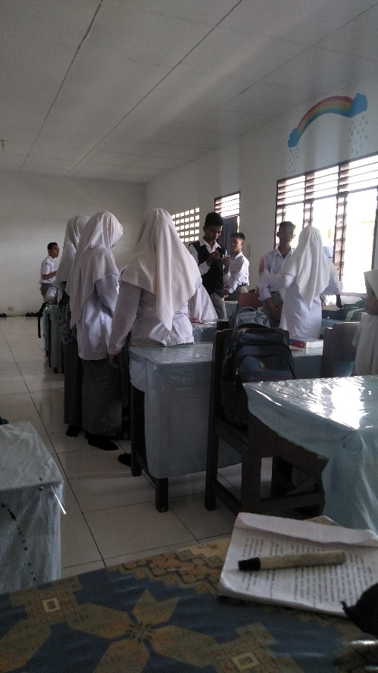
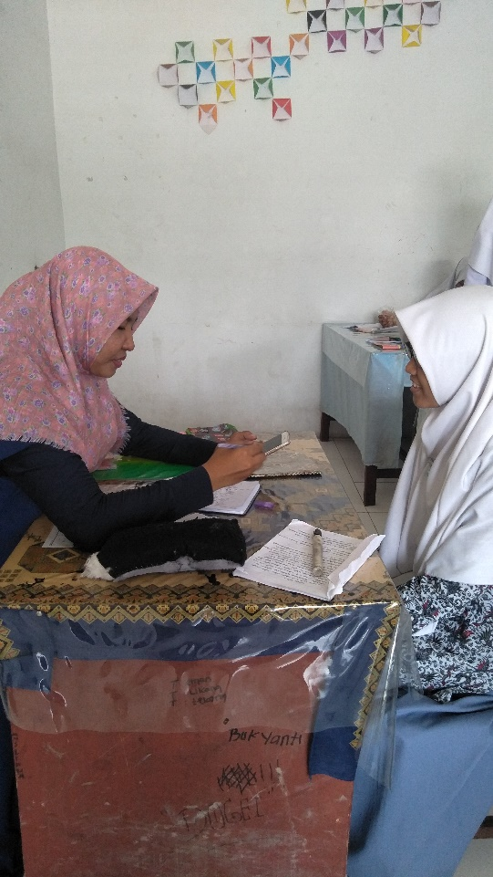
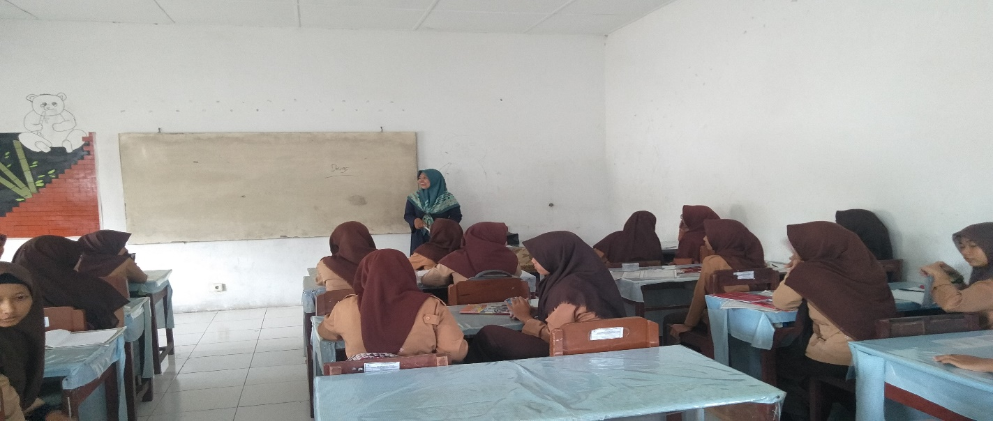

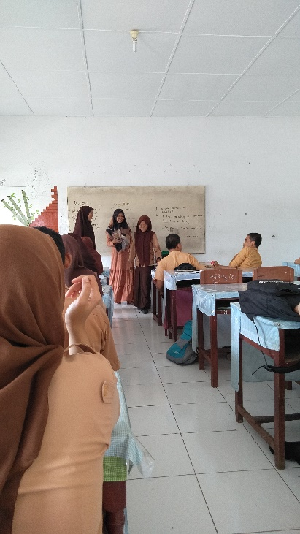
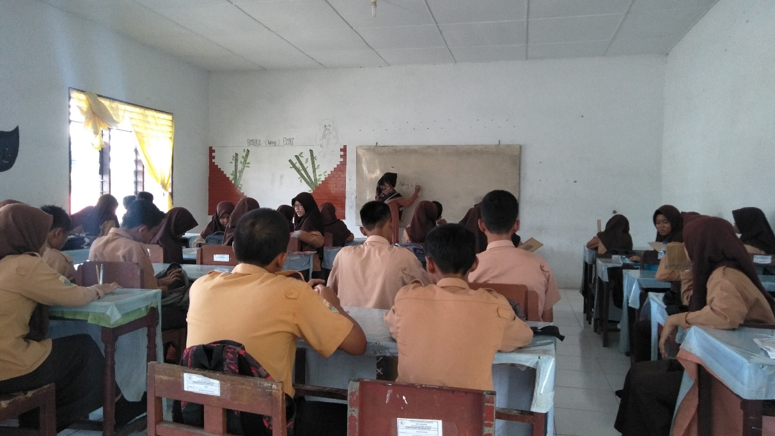
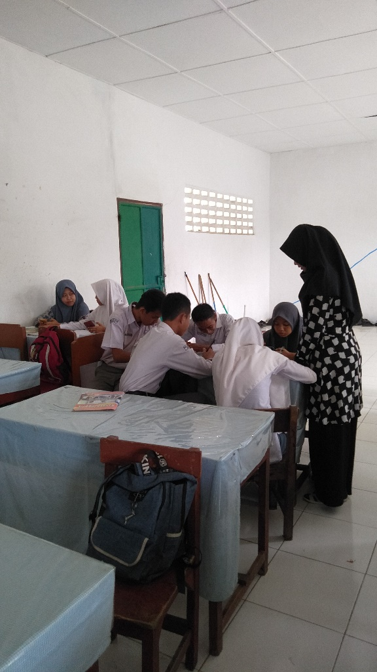

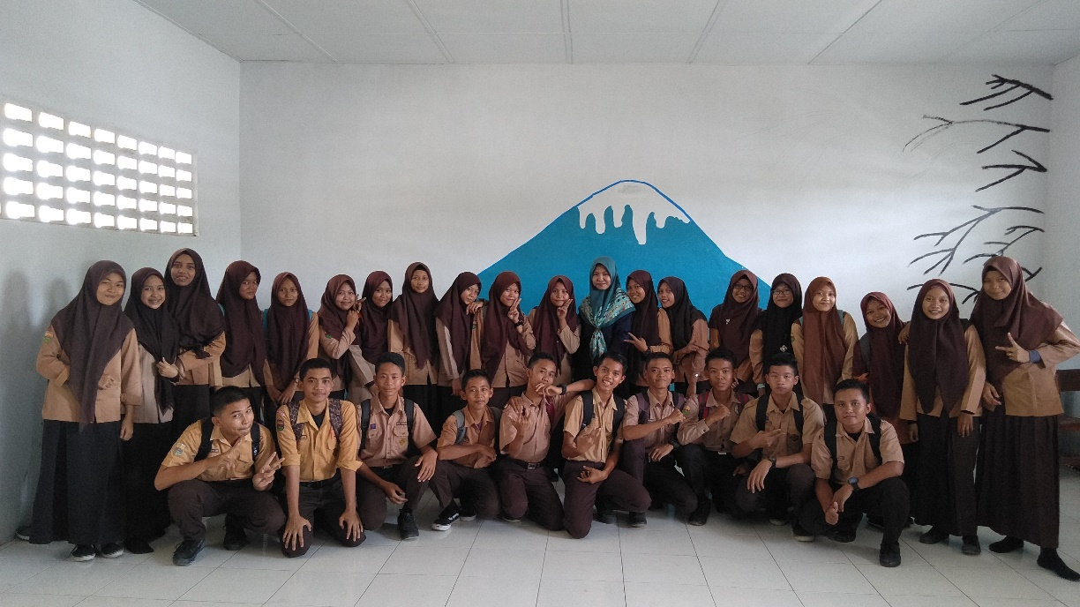

APPENDIX XVII
RESEARCH PERMIT FROM UNIVERSITY
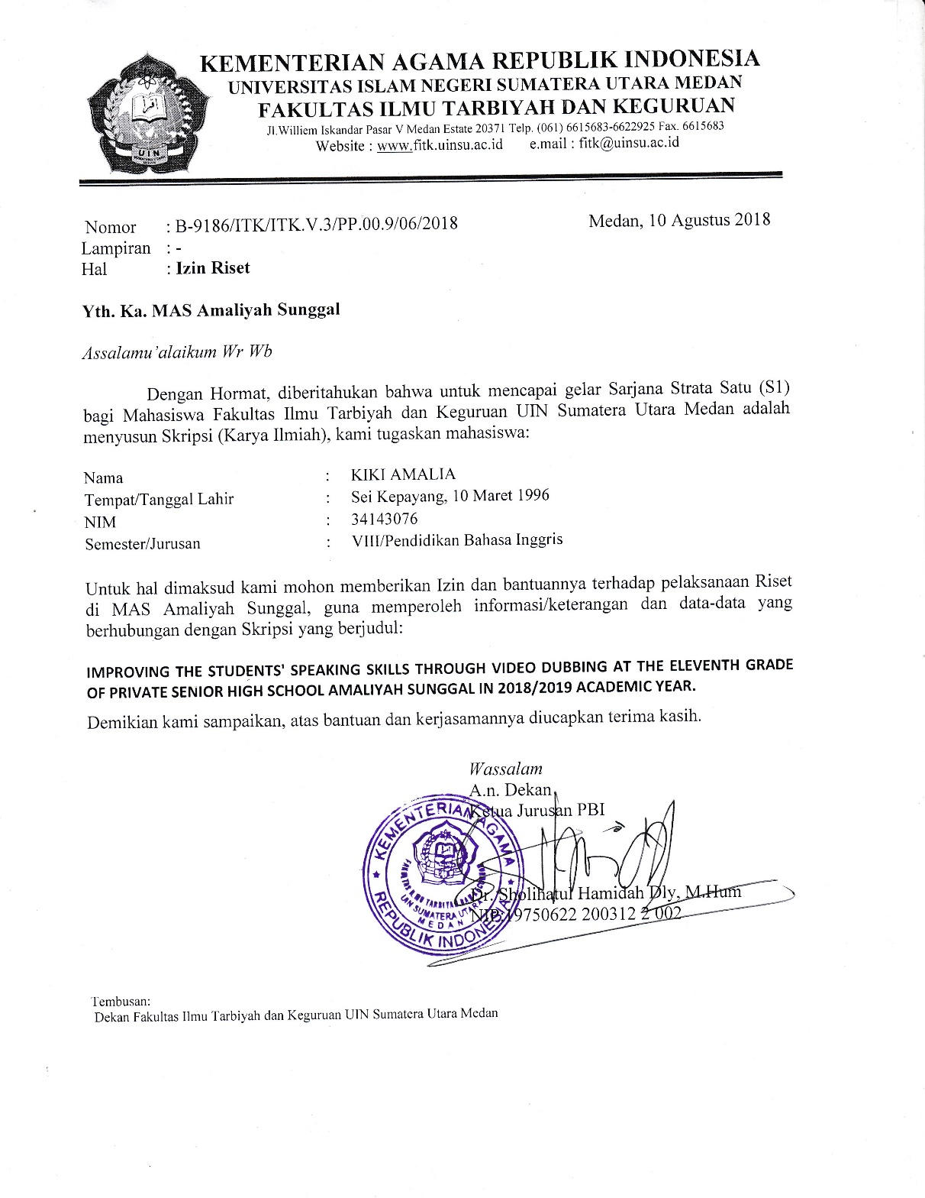

APPENDIX XVIII
CERTIFICATE COMPLETED RESEARCH FROM SCHOOL
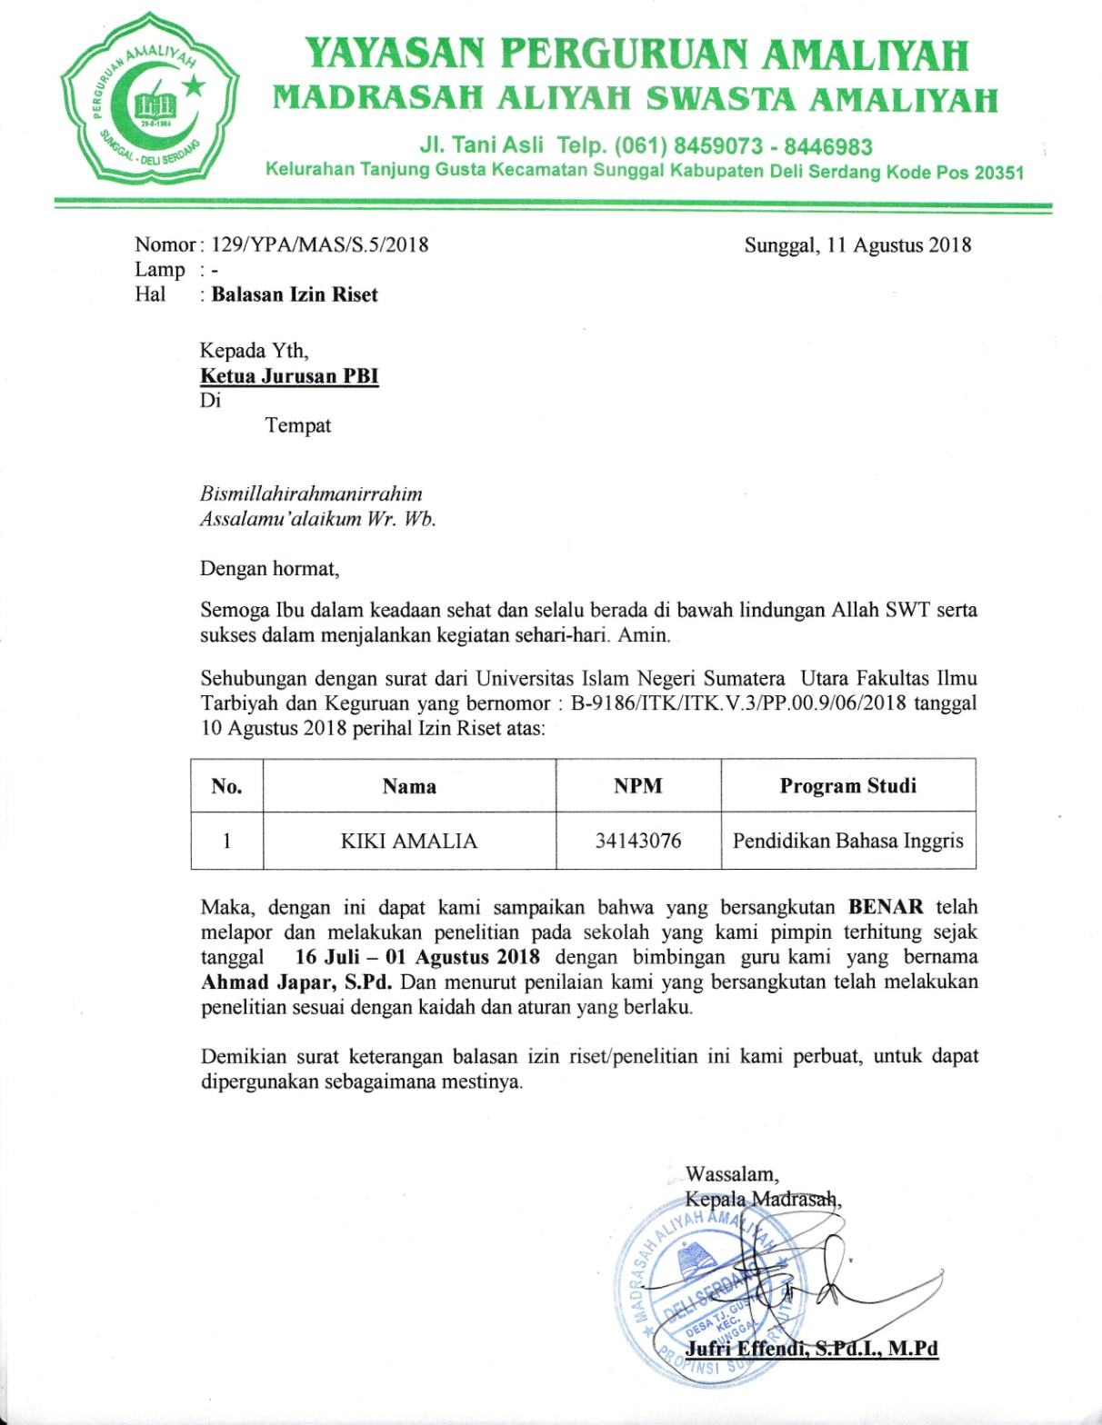

Michelle Maxom, Teaching English as a Foreign Language for Dummies, (West Sussex: John Willey & Sons, 2009), p. 183.
C. Turk, Effective Speaking: Communicating in Speech, (London: Spon Press, 2003), p. 20.
Sherly Rahmawati dan Zul Amri, Using the Lost Twin Game to Improve Pronunciation of Junior High School Students, Journal of English Language Teaching, Vol. 1, No. 2, Maret 2013, p. 557.
D. Nunan & R. Carter, The Cambridge Giude to Teaching English to Speakers of Other Languages. (Cambridge: Cambridge University Press, 2001) p. 21.
Sanda Nuryandi, et.al., Efektivitas Penggunaan Dubbing Film untuk Meningkatkan Kemampuan Berbicara, EDUJAPAN, Vol. 1, No. 1, April 2017, p. 45.
Yi-Hui Chiu, Can Film Dubbing Projects Facilitate EFL Learnes’ Acquisition of English Pronunciation, British Journal of Educational Technology, Vol. 43, No. 1, 2012, p. 24.
Anonymous, define skill at Business Dictionary, accessed from http://www.businessdictionary.com/definition/skill.html, on August 1, 2018, at 11.05 a.m.
Anonymous, define skill at Wikipedia, accessed from https://en.wikipedia.org/wiki/Skill, on August 1, 2018, at 11.48 a.m.
Anonymous, define skill Merriam-Webster, accessed from https://www.merriam-webster.com/dictionary/skill, on August 1, 2018, at 12.17 p.m.
Glenn Fulcher, Testing Second Languge Teaching, (London: Longman, 2003), p. 23.
Gert Rickheit and Hans Strohner, Handbook of Communication Competence, (Germany: De Gruyter Mouton, 2008), p.207.
Hayriye Kayi, Teaching speaking: Activities to Promote Speaking in a Second Language. The Internet TESL Journal, Vol.12, No. 11, November 2006, Retrieved from http://iteslj.org/Articles/Kayi-TeachingSpeaking. html.
Jo McDonough and Christopher Shaw, Materials and Methods in ELT: Second Edition A Teacher’s Guide, (Oxford: Blackwell Publishing, 2003), p. 133.
Didik Santoso, Pengaruh Pendekatan Pembelajaran dan Gaya Belajar terhadap Keterampilan Berbicara Bahasa Inggris, (Medan: Duta Azhar, 2008), p. 28.
Jeremy Harmer, How to Teach English, (England: Longman, 1998), pp. 50-51.
Gerald P. Delahunty and James J. Garvey, The English Language from Sound to Sense, (USA: Parlor Press, 2010), p. 12.
B. Muniandy and S. Veloo, Managing and Utilizing Online Video Clips for Teaching English Language: Views of TESOL Pre Service Teachers, (Singapore: IACSIT : Press, 2011), p. 173.
Yi-Hui Chiu, op.cit., p. 26.
Ibid, p. 24.
Jack Burston, Video Dubbing Projects in the Foreign Language Curriculum, CALICO Journal, Vol. 23, No. 1, p. 80.
Wendy Jolliffe, Cooperative Learning in the Classroom Putting it into Practice, (UK: Paul Chapman Publishing, 2007), p. 3.
Tomgodfrey, Drama in English Language Teaching: A Whole-Person Learning Approach, accessed from https://tomgodfrey.wordpress.com/2010/08/15/drama-in-english-language-reaching-a-whole-person-learning-approach on April 4, 2018 at 01.30 am
Haidir & Salim, Strategi Pembelajaran, (Medan: Perdana Publishing, 2014), p. 126.
Van Dat Tran, Theoretical Prespective Underlying the Application of Cooperative Learning in Classroom, International Journal of Higer Education, Vol. 2, No. 4, 2013, p. 101.
Jack C. Richards and Theodore S. Rodgers, Aproaches and Methods in Language Teaching, (Cambridge: Cambridge University Press, 1986) p. 20.
Ibid, p. 26
I. Cakir, The use of video as an audio-visual material in foreign language teaching classroom, The Turkish Online Journal of Educational Technology-TOJET, Vol. 5, No. 4, Oktober 2006.
Adella Purnama Sari, 2013, about ʺThe Implementation of U-Shape Debate Strategy to Improve Students' Ability at Speaking at MAS Al-Jamiyatul Washliyah 22 Tembungʺ, skripsi. Medan: the Degree of Sarjana Pendidikan State Islamic University of North Sumatera
Rizki Mutiara, 2011, about “Improving Students’ Speaking Achievement Through Realia”, skripsi. Medan : English Literature of UNIMED
Sopinabila Br. Karo, 2016, about “The Implementation of Humor Teaching English Material to Improve Students’ Achievement in Speaking at Grade of XI of Madrasah Aliyah DarulAzharKutacane”, skripsi. Medan: : the Degree of Sarjana Pendidikan State Islamic University of North Sumatera
M. Djuanaidi Ghory, Penelitian Tindakan Kelas,(Malang: UIN Malang Press, 2008) p. 8.
Suharsimi Arikunto, Penelitian Tindakan Kelas, (Jakarta: Bumi Aksara, 2009),p. 6
Brown, H. Douglas, Language Assessment: Principles and Classroom Practices, (New York: Pearson Education, 2004), p. 182.
Anas Sudijono, Pengantar Statistik Pendidikan, (Jakarta: Raja Grafindo Persada, 2014), p. 86.

