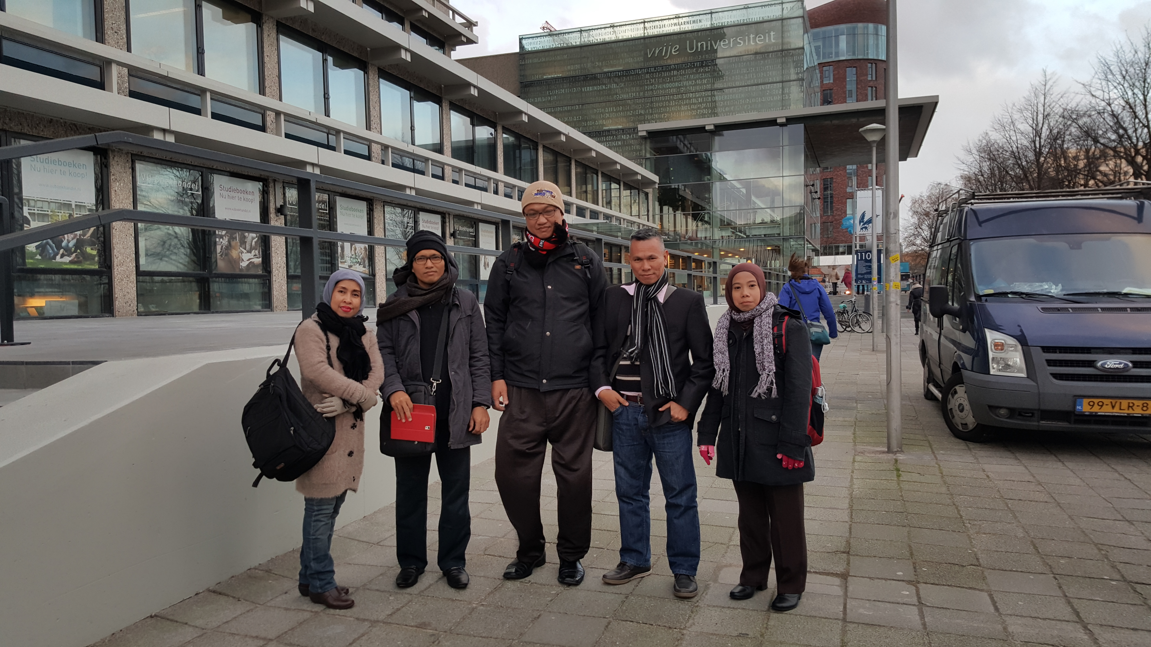

**TRANSFORMATIONAL LEADERSHIP**

Amsterdam, 14-23 Nopember 2015

# DRA. RETNO SAYEKTI, MLIS. UIN SUMATERA UTARA

LAPORAN KEGIATAN TRAINING

*