**BUKTI KORESPONDENSI**

**ARTIKEL JURNAL INTERNASIONAL BEREPUTASI**

|  |  |
| --- | --- |
| Judul artikel | Analysis Of Adolescent Attitudes Towards Massive Free Sex Online On Twitter |
| Jurnal | Waiguo Yuyan yu Wenhua, Volume 8, Issue 06, October, 2024. |
| ISSN | 2096-4366 |
| Penulis | **Nursapia Harahap1**, Anang Anas Azhar2, Fakhrurrozi3, Jamiluddin Marpaung4, Fina Jamaluddin5 |
| Link Jurnal | https://www.waiguoyuyanyuwenhua.com/article/analysis-of-adolescent-attitudes-towards-massive-free-sex-online-on-twitter# |
| Link Scopus | https://www.scopus.com/sourceid/21101063735 |

|  |  |  |
| --- | --- | --- |
| **No** | **Perihal** | **Tanggal** |
| 1 | Bukti undangan menulis | 15 Oktober 2024 |
| 2 | Bukti submission succeeded artikel | 27 Oktober 2024 |
| 3 | Peer review | 27 Oktober 2024 |
| 4 | Accepted artikel | 29 Oktober 2024 |
| 5 | Payment Accepted artikel | 30 November 2024 |
| 6 | Published | 4 Desember 2024 |

Bukti undangan menulis

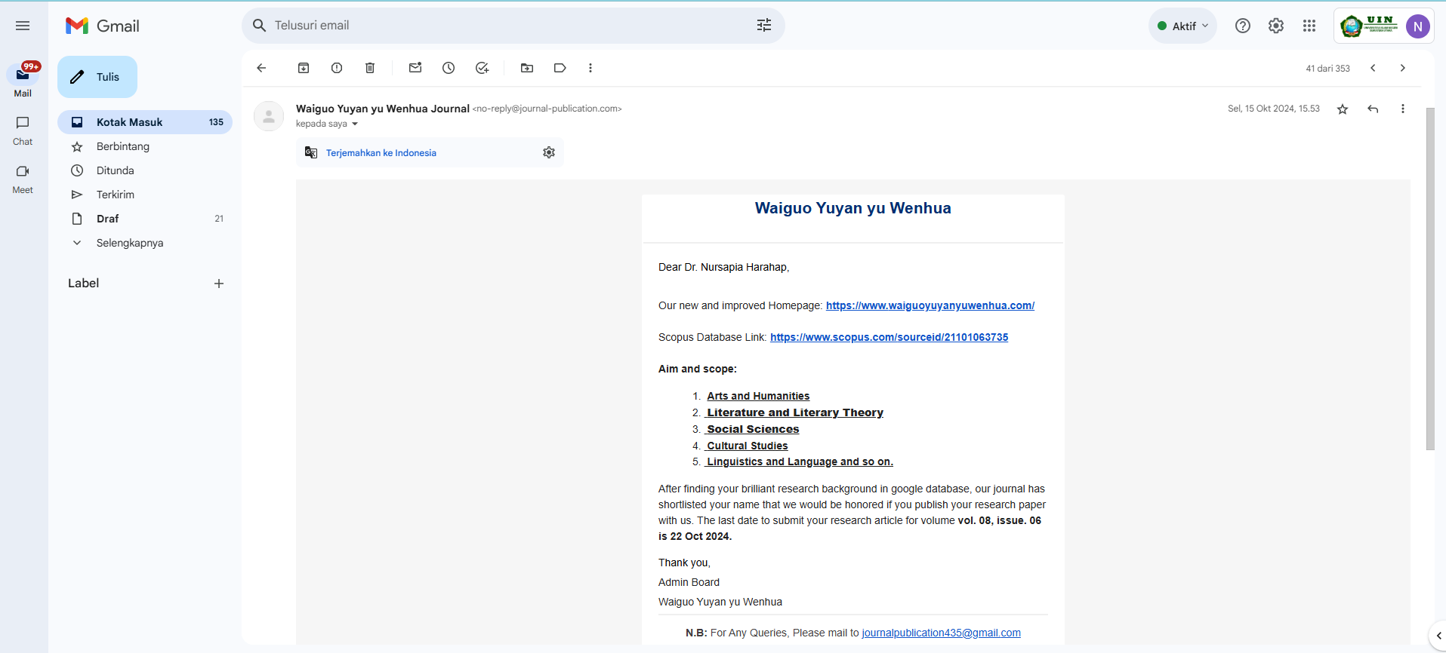

Bukti submission succeeded artikel

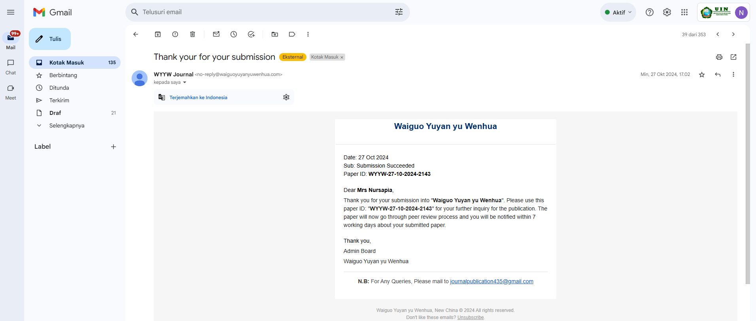

Bukti accepted artikel

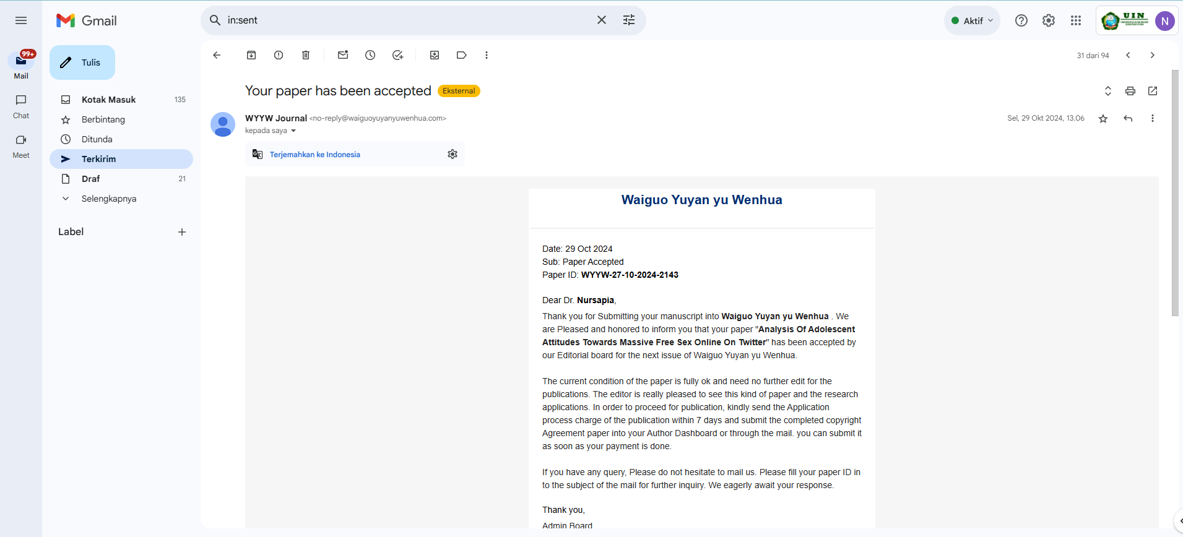

Payment Accepted artikel

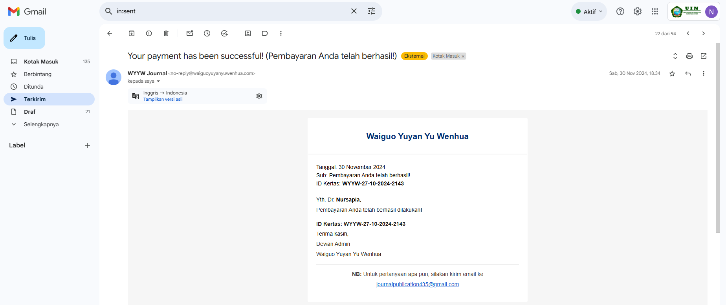

Bukti published artikel

